# INVENTORY AND CHECK OUT PREPARED FOR

21 WALDEGRAVE ROAD

EALING

LONDON

W5 3HT

28TH JULY 2018/20TH JANUARY 2021

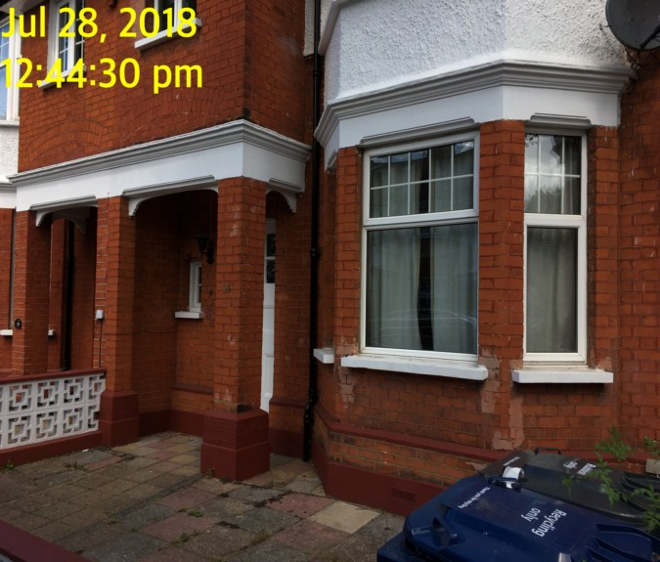

|  |  |
| --- | --- |
| **CLIENT:** | Thorgills |
| **INSTRUCTED BY:** | Chantelle Leydon |
| **TENANT:** | Alicia Wilson |
| **REF:** | MBPS-002/ MBPS-002 |
| **INSPECTED BY:** | Rae Hicks |
| **PROPERTY SIZE:** | 2 Reception / 5 Bedrooms / 1 Bathroom / 1 kitchen / 1 Staircase & landing/ 1 Front and Rear Garden - Furnished House |

'WINDY RIDGE' [99 COWLEY HILL, BOREHAMWOOD, HERTS, WD6 5NA](https://maps.google.com/?q=99+COWLEY+HILL,+BOREHAMWOOD,+HERTS,+WD6+5NA&entry=gmail&source=g),    TEL: 020 8 386 0950 - MOBILE: 077 67 647 647  
EMAIL: [info@inventorys.net](mailto:info@inventorys.net)  [www.inventorys.net](http://www.inventorys.net/)  
Registered No: 4263261 VAT No: 822 9322 12

Safety Disclaimer

This inventory report is prepared as an ‘as seen snapshot’ of the property and its contents at the time of the designated inspection and is compiled as a fair and accurate record for the properties internal condition and contents. This does not form any part of a valuation or structural report.

This inventory is compiled on the basis that all items listed are in good order and clean. Any defects or soiling are noted where appropriate. Where inspections are carried out and the tenants’ belongings are in situ, it can be difficult for clerks to differentiate to that belonging to the landlord or tenant. Should the report contain inaccuracies the clerk (Independent Inventories (UK) Ltd ) will not be held responsible.

The clerk preparing the inventory is not an expert in electrical appliances, antiques, furniture style, fabrics, flooring, etc. All descriptions within this report are for identification purposes only in order that each item can be compared to its condition at the commencement of the tenancy.

Lofts and Cellars are not included unless they are converted and safely accessible. Contents will therefore not be noted or checked at checkin or checkout.

Plants and shrubs will not be itemised.

Belongings left by the landlord/agent in a locked room or outbuilding will not be inventoried and are the sole responsibility of the Landlord/agent. Items in garages/sheds such as garden equipment and tools will be inventoried, however tins of paint will not be itemised.

We do not undertake to move heavy items of furniture or access lofts, high-level cupboards, or any other inaccessible places. Contents which have been left in the above-mentioned areas, which have not been inventoried, are the sole responsibility on the landlord. We also do not undertake to open windows, but will confirm whether keys have been seen or not.

Any electrical appliances tested will be for power only and only where practicable. The clerks are not qualified electricians and will only confirm the visual condition of the electrical socket, wiring and or fitting as seen. Boilers, Heating Systems, Gas Fires, Water Supply and Radiators are not tested, and Independent Inventories (UK) Ltd will not take any responsibility for units left either on or off even if on automatic timers. Where smoke alarms and CO Detectors are tested this is for power only and should not be taken to mean that the alarms are in full working order. We only state their presence and cannot state the functioning of this equipment. No responsibility is taken for any damage or malfunction occurring during the testing of such alarms.

The relevant utility companies must check all meter readings, as we cannot be held responsible for any discrepancies. We are not held liable should meters not be located or inaccessible to read. For Health and Safety reasons we do not expect our clerks to access high level areas which involve using ladders/chairs.

The Fire & safety Regulations regarding furnishings, gas, electrical & similar services are ultimately the responsibility of the instructing principle. Where the inventory notes FFR label seen, this should not be interpreted to mean that the item complies with the furniture & furnishings (fire) (safety) (Amendments) 1993. It is a record that the item had a label as described or similar to that detailed in the Guide to the regulations as published by the Department of Trade & Industry, January 1997, (or subsequent edition), attached at the time the inventory was complied.

Blinds in the premises are visually checked. We are unable to verify that the blinds comply with child safety requirements of BS EN 131202009 + A1:2014 placed on the manufacturer, supplier and professional installation of internal window blinds

It is the responsibility of the landlord/managing agent/tenant to agree between themselves the accuracy of the report, and Independent Inventories (UK) Ltd should be notified within 7 days of receipt of the report of any discrepancies within the report.

GENERAL GUIDANCE NOTES

Independent Inventories do not have site of tenancy agreements or other agreements made between the tenant, landlord and management company. As these are guidance notes only it is always advisable that the tenancy agreement is cross referenced. This report will indicate whether in our opinion the tenant is liable for the deterioration or whether it is considered fair wear & tear. Independent Inventories may suggest maintenance, cleaning or tenant’s liability at checkout, but the final responsibility of these suggestions will fall with the landlord or managing agent in respect of the original tenancy agreement. We do not suggest costs of any items, these should be sourced from the relevant contractors by the landlord or managing agent.

CLEANING

We recommend that a professional cleaning company is employed at the end of the tenancy, unless alternative arrangements have been agreed with the Landlord/Managing Agent. Receipts from professional cleaning and carpet cleaning companies must be present to the clerk at the checkout inspection.

If the standard of cleaning is not satisfactory most Landlords/Managing Agents will contract a cleaner and their charges will be charged to the tenant unless otherwise stated in the tenancy agreement.

DECORATION

It is accepted that during the course of the day to day living scuffs will appear on walls and woodwork. However should the marks be found to be excessive charges will be made to you the tenant, unless otherwise stated in the tenancy agreement.

LIGHTING

If the lights are working at checkin then it is normal, if lights are not working at checkout, for these to be the responsibility of the tenant to replace bulbs or to be charged accordingly, unless otherwise stated in the tenancy agreement.

GARDENS/PATIO

If the standard of the garden/patio is found to be untidy compared to the start of the tenancy the Landlord/Managing Agent are entitled to employ a contract gardener and the charge will be made to you the tenant, unless otherwise stated in the tenancy agreement.

MAINTENANCE ISSUES

We recommended should any maintenance issues arise you contact the Landlord/Managing Agent immediately so they can deal with the matter. Should we recommend items require maintenance once a property has been checked out, this is purely stating that an item will require fixing/attention, we are not advising as to whose responsibility this and your tenancy agreement will need to be checked.

CHANGES TO PROPERTY

We recommend that if you wish to make any changes to the décor or remove any of the Landlords belongings you contact the Landlord/Managing Agent for permission and have this confirmed in writing to ensure there are no discrepancies at the end of the tenancy.

TENANTS INFORMATION FOR CHECKING OUT OF PROPERTY

It is important at the checkout that:

1. All cleaning should be completed prior to the checkout appointment as per the tenancy agreement.
2. All personal items must be removed prior to the check out.
3. All items should be in the same location as per the inventory, any stored items should be unpacked and also returned to the same location.
4. If the Inventory clerk has to search for items or you still have belongings in the property to be removed this will result in additional charges being made to the tenant.
5. All beds should be left unmade with the linen folded. Bedding & towels should be cleaned & ironed where relevant.
6. All food items should be removed, freezers defrosted & doors left open & electricity turned off.
7. All light bulbs etc. should all be in working order as at check in.

The property should be left in a clean and tidy condition especially carpets, curtains, windows, upholstery appliances etc. We would suggest that you refer to your tenancy agreement in this matter.

If you are not ready to leave it may not be possible to carry out the checkout. In this case a return visit will be necessary resulting in a cancellation charge.

All keys to the property must be handed over at the time of checking out to the Inventory clerk or alternatively to the agents prior to the check out taking place.

The Inventory Clerk acts as an independent and reasonable body and will avoid unnecessary criticism or derogatory comments when compiling or checking the Inventory.

At the termination of the tenancy the inventory will be checked and any obvious or significant discrepancies will be reported to the Managing Agent/Instructing Principal. This report will indicate whether in our opinion the tenant is liable for the deterioration or whether it is considered fair wear & tear. Normal fair wear and tear will be assessed on the lengthy of the tenancy and type occupancy.

INDEX

PAGE

|  |  |
| --- | --- |
| UTILITY READING | 1-2 |
|  |  |
| KEYS | 3 |
|  |  |
| GENERAL SUMMARY AT CHECKIN | 4 |
|  |  |
| INSTRUCTION MANUALS | 5 |
|  |  |
| FRONT OF PROPERTY | 6-7 |
|  |  |
| ENTRANCE HALLWAY | 8-11 |
|  |  |
| DINING ROOM | 12-16 |
|  |  |
| KITCHEN | 17-29 |
|  |  |
| BEDROOM 1 | 30-35 |
|  |  |
| RECEPTION | 36-41 |
|  |  |
| STAIRS AND LANDING | 42-44 |
|  |  |
| BATHROOM | 45-51 |
|  |  |
| BEDROOM 2 | 52-56 |
|  |  |
| BEDROOM 3 | 57-61 |
|  |  |
| BEDROOM 4 | 62-67 |
|  |  |
| BEDROOM 5 | 68-72 |
|  |  |
| GARDEN | 73-74 |
|  |  |
| DECLARATION AT CHECK IN | 75 |
|  |  |
| ADDITIONAL AMENDMENTS | 76 |
|  |  |
| SIGNED SCHEDULE OF CONDITION AT CHECK IN |  |

**UTILITY READINGS / KEY LIST& INSTRUCTION MANUALS**

|  |  |  |
| --- | --- | --- |
| **ELECTRIC** | **GAS** | **WATER** |
| METER NUMBER:  Z05SP22069 | METER NUMBER:  N/A | METER NUMBER:  N/A |
| READING:  52052.21 | READING:  N/A | READING:  N/A |
| LOCATION:  Utility cupboard area in dining room | LOCATION:  N/A | LOCATION:  N/A |
| SUPPLIER: | SUPPLIER: | SUPPLIER: |

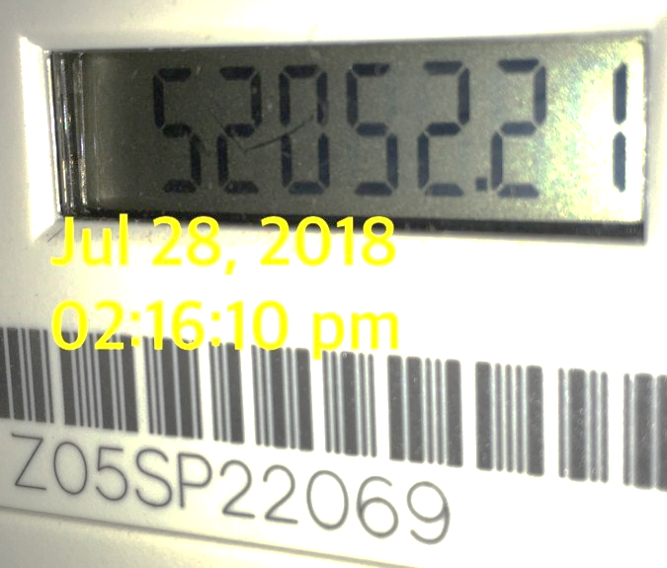 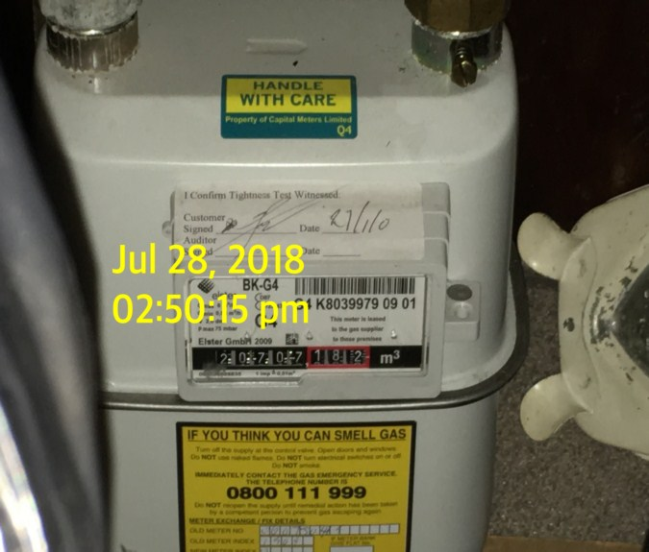

|  |  |  |
| --- | --- | --- |
| **ELECTRIC** | **GAS** | **WATER** |
| METER NUMBER:  Z05SP22069 | METER NUMBER:  G4 K8039979 09 01 | METER NUMBER:  Unknown |
| READING:  5627985 | READING:  23325 | READING:  Unknown |
| LOCATION:  Utility cupboard in dining room | LOCATION:  Utility cupboard in dining room | LOCATION:  N/A |
| SUPPLIER: | SUPPLIER: | SUPPLIER: |

|  |
| --- |
| **LOCATION OF:** |

|  |  |  |
| --- | --- | --- |
| **STOP COCK** | Dining room utility area cupboard | |
| **FUSE BOARD** | Dining room utility area cupboard | |
| **ALARM PANEL**  **This has not been tested** | N/a | MAKE: |

|  |
| --- |
| **FIRE SAFETY** |

|  |  |
| --- | --- |
| **SMOKE ALARM 1** | Power light on  Tested with canned smoke and working order  Location: kitchen  Expiry Date: February 2020 |
| **SMOKE ALARM 1** | Power light on  Tested with canned smoke and working order  Location: Entrance hall  Expiry Date: Too high to read |
| **SMOKE ALARM 1** | Power light on  Tested with canned smoke and working order  Location: landing  Expiry Date: Too high to read |
| **CARBON MONOXIDE ALARM** | Not seen |

0

|  |  |  |
| --- | --- | --- |
| **KEYS AT CHECKIN** | **KEYS AT CHECKOUT** | |
| **KEY TYPE / SERIAL NUMBER / QTY** | **KEY TYPE / SERIAL NUMBER / QTY** |
| 1 x Set comprising Mortise | 5 x yale cylinder |
| 2 x Cylinder keys | 2 x brass mortise |
|  | 3 x chrome mortise |
|  |  |
|  |  |
|  |  |
| **KEYS RECEIVED BY:** Returned to agent **-** Ealing Office  \\Pc-1\mbps\II\29TH JULY\29TH JULY\21 WALDEGRAVE ROAD - MAKE\New folder\Photo 28-07-2018, 14 22 01 (Copy).jpg  Patio doors do not open as the keys are broken | **KEYS RETURNED TO:AGENT** | |

|  |
| --- |
| **GENERAL SUMMARY** |

|  |  |  |
| --- | --- | --- |
| **ITEM** | **CHECKIN NOTES** | **CHECKOUT NOTES** |

|  |  |  |  |
| --- | --- | --- | --- |
| **GENERAL CONDITION** | | Professionally cleaned for start of tenancy  Further general cleaning required | Domestically cleaned for the end of tenancy  Further general cleaning required  Tenants items left in property |
| **ODOUR** | | N/A | N/A |
| **DECORATIVE ORDER / WOODWORK** | | Good order  Defects as noted | Defects as noted  Dusty  Woodwork scuffed/chipped |
| **FLOORING** | | Good order , Defects as noted  Vacuumed for start of tenancy  Professionally cleaned | Defects as noted |
| **CURTAINS / BLINDS** | | Vacuumed in situ for start of tenancy  Requires further cleaning  Good order | Defects as noted |
| **BLIND REGULATIONS** | | N/A |  |
| **UPHOLSTERY** | | Vacuumed for start of tenancy | Defects as noted |
| **FFR LABELS** | FFR labels seen | |  |
| **LINEN** | None provided | | In use  Requires further cleaning |
| **LIGHTS** | As noted | | Bulbs missing / not working |
| **KITCHEN / APPLIANCES** | All appliances power tested  Fridge/ freezer left shut power on  Requires further cleaning | | All appliances power tested  Requires further cleaning  Fridge/ freezer left shut power on |
| **BATHROOMS/**  **WC** | Water outlets tested and working  Mildew to areas as noted  Requires further cleaning  Water level goes down very slowly and toilet does not flush very well – potential blockage | | Mildew to areas as noted  Requires further cleaning  Water outlets tested and working where accessible |
| **WINDOWS** | Fitments complete / Clean to both sides | | Clean to interior  Requires further cleaning |
| **GARDEN /**  **TERRACE** | Seasonal order  Further attention required | | Seasonal order  Further attention required |

|  |  |
| --- | --- |
| **MANUALS SUPPLIED AT**  **CHECKIN** | **MANUALS RETURNED AT**  **CHECKOUT** |
| **APPLIANCE / MAKE** | **APPLIANCE/MAKE** |
|  | NONE |
|  |  |
|  |  |
|  |  |
|  |  |

 *N.B – Heavy items will not be moved or inspected behind/under, for health & safety reasons. We will not be held liable should any damages/stains/marks be found during the tenancy in these areas. Should the occupant find any of the above they should, inform the landlord/agent immediately and if/where possible take photographic evidence and pass to the relevant parties.

 This camera symbol throughout the Inventory check in/out indicates where a photo has been taken. Photos can be found at the back of each room in the report with the relevant headings

**FRONT OF PROPERTY**

|  |  |  |  |
| --- | --- | --- | --- |
| **Borders** | White and red painted stone with  Front and left to right is wooden fence  Facing border outside of house is red brick work  Brass metal number “21”  Low White metal gate to facing border | 1. Right hand fence is heavily weathered with some loose slats 2. General weathering and discolouration throughout 3. Tarnishing to metal fittings |  |
| **Lighting** | Black metal lamp next to entrance | 1. External light ~~appears not to be functioning~~ is working |  |
| **Door bell** | Brass metal door bell | 1. Intact 2. Tested and working |  |
| **Paving** | Coloured patchwork paving | 1. Weed grows throughout 2. Heavily faded overall appearance / discoloured 3. Rubbish left on powering |  |
| **Window ledge** | White painted window ledges outside of the reception | 1. Few cracks to paint |  |
| **Additional items** | Blue and black refuse bins  2 x green plastic recycling boxes | 1. Both are completely filled 2. Recycling boxes also filled |  |
| **Step** | Painted red | In use |  |

Front of property Front of property

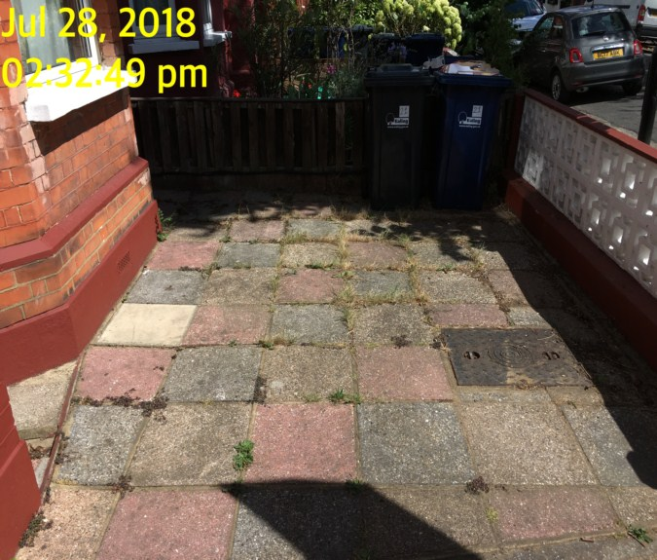 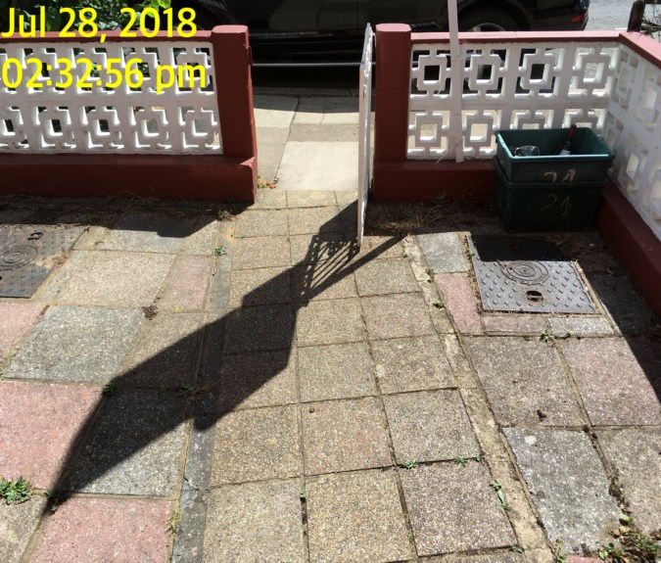

Front of property Front of property

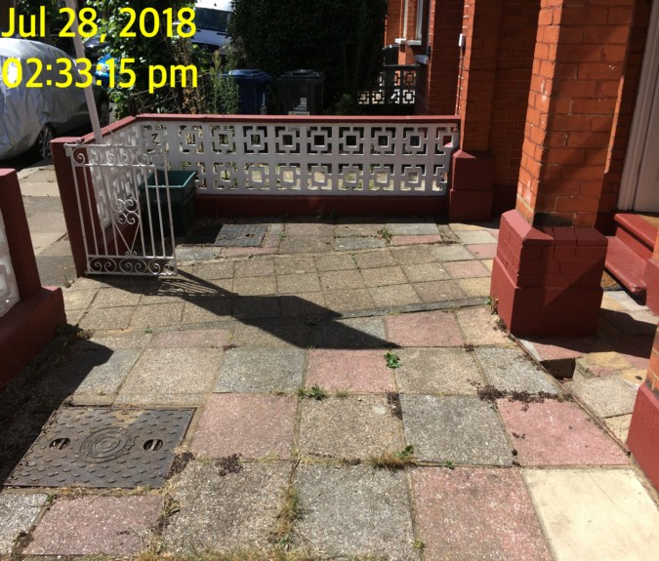 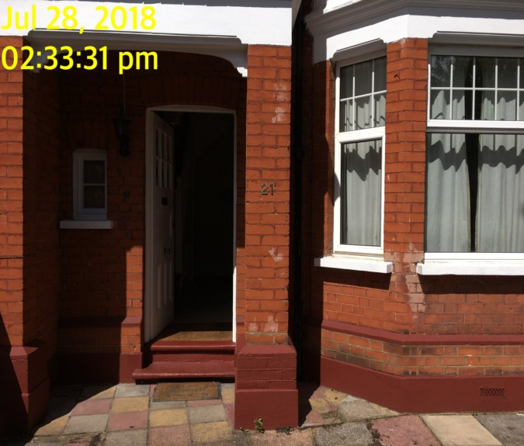

**ENTRANCE HALLWAY**

|  |  |  |  |
| --- | --- | --- | --- |
| **Door** | Exterior Door Frame  Wood painted white  Threshold is red painted stone step | 1. Some paint marks to the glass |  |
|  | Exterior Door  White painted wooden panelled door with 6 x glass panels  Exterior has number “21”  Letterbox, cylinder lock mortise and door knob | 1. Tarnishing to the metal fittings on exterior |  |
|  | Interior Door Frame  Wood painted white |  |  |
|  | Interior Door  Reverse has handle, security chain catch, lock box and letterbox | Top right hand side of letterbox is slightly loose, scratches to letter box  No surround for lock above chain  Yellowish knot middle of centre panel below letter box |  |

**ENTRANCE HALLWAY**

|  |  |  |  |
| --- | --- | --- | --- |
| **Walls** | Painted magnolia with picture rail and dado rail  Mirror – (Right hand side wall) | 1. Left hand wall has dark smudging at the foot of the stairs high level      1. Odd scuff to walls 2. Not clear in CI photos, see if it is the same |  |
| **Ceiling** | Painted white with matching coving | 1. Cobwebs to corner  2. Few opening places near facing wall |  |
| **Lights** | Brass metal light fitting by the entrance with 3 x bulbs fitting and glass shade | 1. ~~2 x bulbs are not present~~ only 1 x bulb not present |  |
| **Woodwork** | Skirting is painted white | Scattered rubs and scuffs |  |
| **Switches and sockets** | Range of light switches all in white plastic | 1. All intact |  |

**ENTRANCE HALLWAY**

|  |  |  |  |  |
| --- | --- | --- | --- | --- |
| **Windows** | Stained glass window with shape of ship looking onto dining room |  |  |  |
| **Flooring** | Fitted grey carpet  Fitted coir mat by entrance | 1. Small light debris to corner 2. Not clean |  |  |
| **Radiator** | Double panelled white metal radiator | 1. Right hand valve cap is missing |  |  |
| **Wardrobe** | Light wood effect laminate and white laminate wardrobe with double doored and single doored compartment  Left hand side has single shelf, white metal clothing rail    Right hand side has 3 x shelves, 2 x drawers | 1. Back panel is coming apart down to the centre 2. 2 x handles on right hand side broken 3. Right hand side double door is dropped – not aligned 4. Numerous items left to interior 5. Cables, 4 x pillows, duvets, hammer, broadband, window blind, blue bag, 2 x large white plastic bags with items |  |  |
| **Thermostat** | Wall mounted grey plastic thermostat with digital display | 1. Not Tested ~~and working~~ 2. Intact |  |  |
| **Additional** | Items left on window sill |  |  |  |

Hallway Hallway

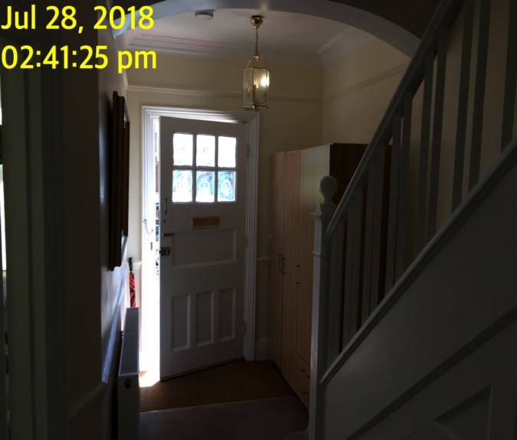 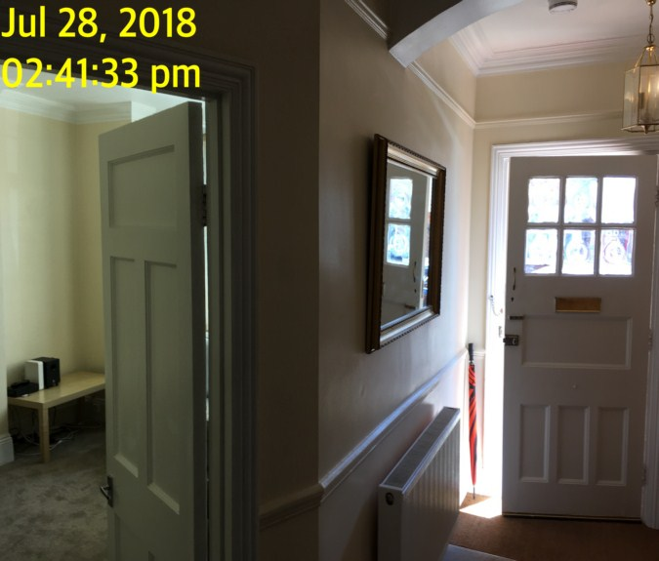

Hallway Hallway

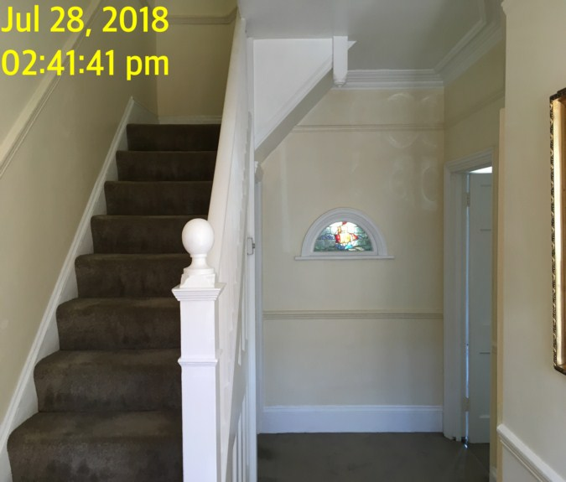 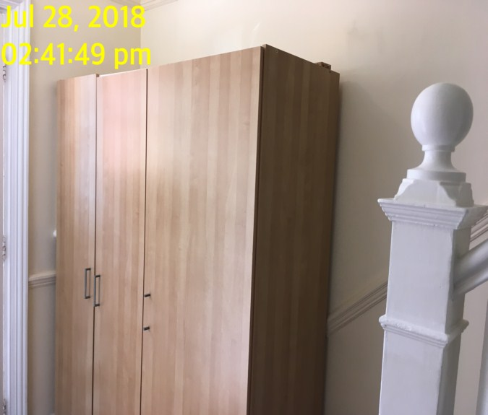

Hallway Hallway

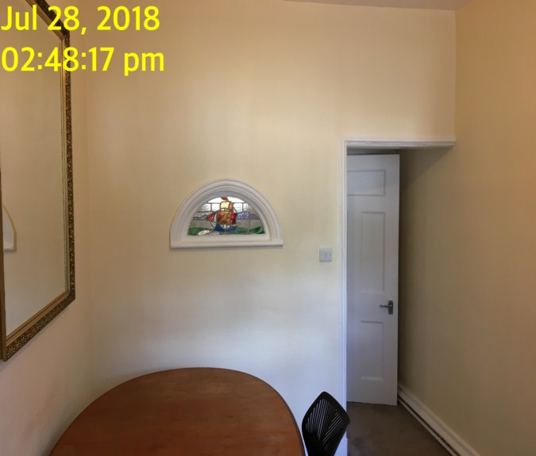 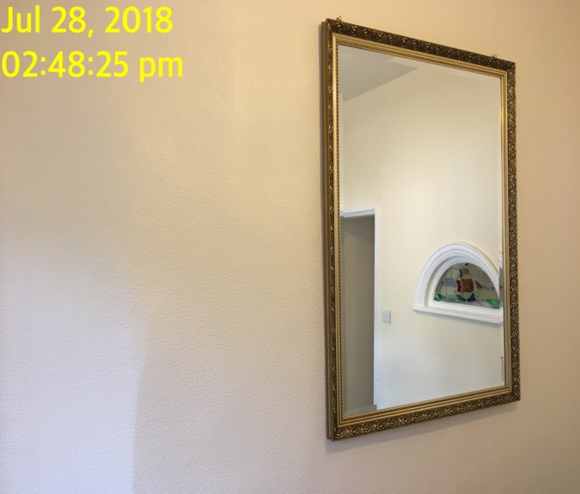

**DINING ROOM**

|  |  |  |  |
| --- | --- | --- | --- |
| **Door** | Exterior Door Frame  Matching threshold with silver metal strip |  |  |
|  | Exterior Door  White painted wooden panelled surface  Chrome lever handle |  |  |
|  | Interior Door  White painted wooden panelled surface  Chrome lever handle |  |  |
| **Walls** | Painted cream with textured surface | Scattered rubs/scuffs to walls |  |

**DINING ROOM**

|  |  |  |  |
| --- | --- | --- | --- |
| **Ceiling** | Painted white |  |  |
| **Lights** | White plastic pendant ~~fitting without shade~~ with 3 bulbs | 1. ~~Tested and working~~ 1 x bulb missing |  |
| **Woodwork** | Skirting painted white | Scattered rubs/scuffs |  |
| **Switches and sockets** | Range of light switches, main outlets white plastic | 1. All intact |  |
| **Windows** | Double glazed in white UPVC casement with matching lockable lever handle fixture  Sill in dark brown wood stained shelf | 1. Handle is slightly discoloured 2. No key 3. Some minor paint spots to sill |  |

**DINING ROOM**

|  |  |  |  |
| --- | --- | --- | --- |
| **Curtains** | ~~Roller blind white and green with white plastic~~~~beaded chain~~ | 1. ~~Tested and working~~ 2. ~~Not safety complaint~~ |  |
| **Flooring** | Grey fitted carpet | Furniture pressure marks |  |
| **Radiator** | Double panelled white metal radiator  Thermostatic valve to right |  |  |
| **Mirror** | Wall mounted gold effect framed vertical mirror  Small mirror mid wood effect |  |  |
|  | Wall mounted unit pair of plastic sliding doors  White laminate ~~unit containing variety of~~ mugs, glasses and crockery – not in unit but crockery seen in kitchen | 1. Slightly grubby inside      1. Left hand side bottom edge of right hand side door cracked |  |

**DINING ROOM**

|  |  |  |  |
| --- | --- | --- | --- |
| **CD unit** | Freestanding green laminate CD unit with multi compartment - now located in reception |  |  |
| **~~Picture frame~~** | ~~Mid wood frame picture frame~~ | 1. ~~No glass~~ |  |
| **Additional** | Grey mop bucket, blue bin, red bin, large white chair, wooden chair with yellow, grey, green seat |  |  |
| **Table** | Large oval shaped wooden table | 1. Varnish to top is heavily worn |  |
| **Chair** | Black fabric and chrome swivel chair | 1. Slightly grubby to seat |  |
| **Fridge freezer** | Freestanding white plastic and metal fridge | 1. Serial number not seen 2. Brand not seen 3. Item ~~is not tested~~  Power seen 4. Not clean 5. Small dent to door |  |
| **Utility area** | Single white painted wooden panelled door  Dark brown wood stain to walls and ceiling to interior  Grey carpet to floor  Gas meter, electricity meter mounted to wall  ~~Red and black Henry~~ Bush hoover  White plastic light switch  Bayonet light fitting ~~without~~ bulb  Large amount of discarded general household items | Fitment for top lock missing  Cobwebs to walls  Needs cleaning  Working  Additional items seen not visible in CI photos |  |

Dining room Dining room

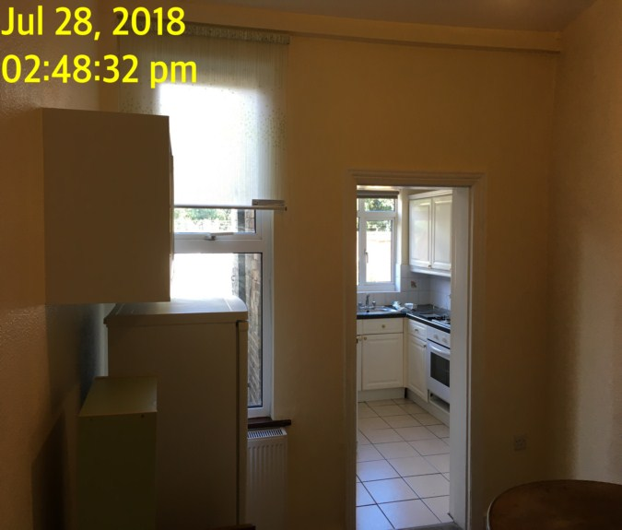 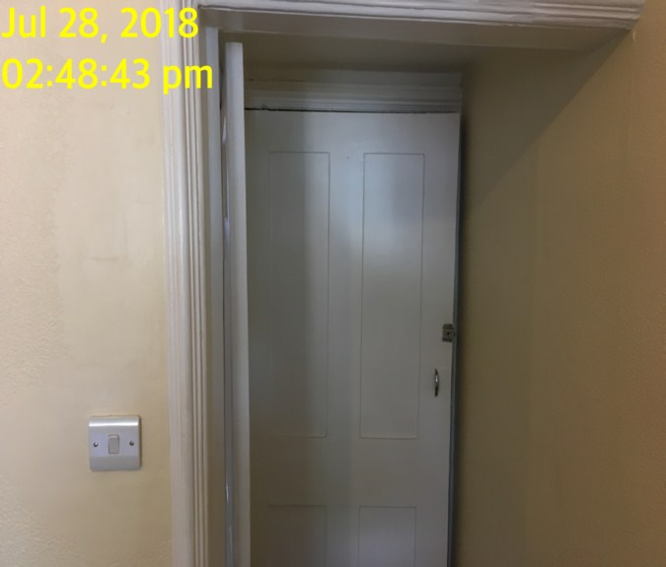

Utility area Utility area

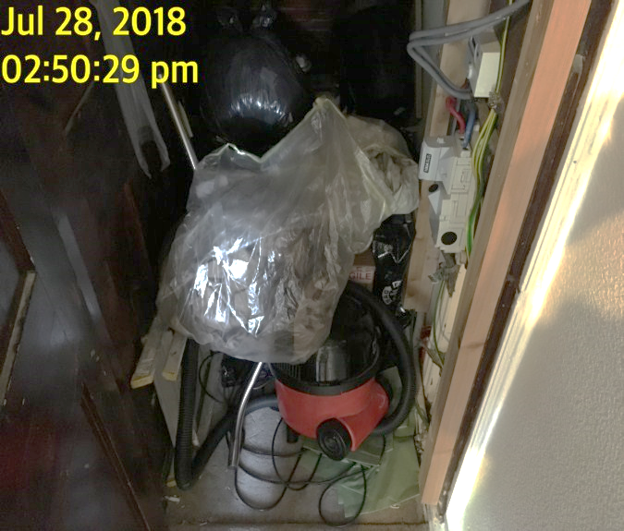 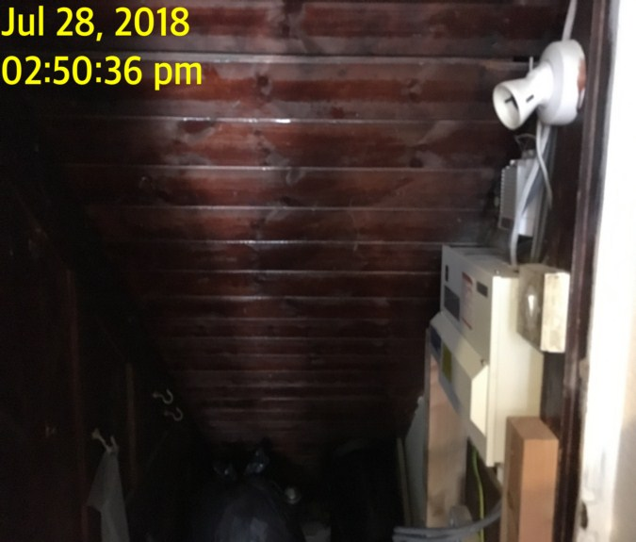

**KITCHEN**

|  |  |  |  |
| --- | --- | --- | --- |
| **Door** | Door Frame  Wood painted white  Silver metal strip threshold |  |  |
| **Walls** | Painted magnolia with white floral design tiling around work surface | 1. Tiling has large amount discolouration generally to grout 2. Some minor marks on the back wall at low level 3. 4 x tiles slightly lifting left hand side 4. Left hand side – stress crack near switch |  |
| **Ceiling** | Painted white  Smoke alarm  Carbon monoxide | Joint showing middle and forward of door  Working  Working |  |
| **Lights** | 4 ceiling mounted down lights | 1. ~~All tested and working~~   1 x no bulb, 1 x not working |  |
| **Woodwork** | Skirting painted white | Scattered rubs/ scuffs |  |

**KITCHEN**

|  |  |  |  |
| --- | --- | --- | --- |
| **Switches and sockets** | Range of light switches, main outlets and isolator switches all in white plastic | 1. All intact 2. Needs final wipe |  |
| **Windows** | Double glazed and white UPVC casement with 2 x lockable lever handle fixtures  Garden access door which is double glazed in white UPVC casement and frame with matching transom above the glass is obscured  Door has in-built lockable lever handle fixture with cylinder lock and single cylinder key | 1. No keys in situ 2. Discolouration to handles 3. Handle lock is chipped and scratched 4. All 3 x hinges discoloured |  |
| **Flooring** | Beige tiling | 1. Tiling heavily discoloured throughout 2. Chips to tiles by far end of the room 3. Not clean 4. White towel on floor – not clean |  |

**KITCHEN**

|  |  |  |  |
| --- | --- | --- | --- |
| **Unit Description - Units are inspected from left to right** | White panelled doors with brass door pulls  White plinths and pelmets | 1. Chipping and cracking to units  2. Needs cleaning. Stains in shelves |  |
| **Wall unit 1** | Single cupboard with 2 shelves |  |  |
| **Wall unit 2** | Single cupboard with 2 shelves | Items to interior – possibly from dining area |  |
| **Wall unit 3** | Boiler cupboard | Valiant boils – bottom of cupboard is loose |  |
| **Wall unit 4** | Single cupboard with 2 shelves |  |  |
| **Wall unit 5** | Single cupboard with 2 shelves |  |  |
| **Wall unit 6** | Integrated panel to extractor hood | White panel cover is missing |  |
| **Wall unit 7** | Single cupboard with 2 shelves |  |  |

**KITCHEN**

|  |  |  |  |
| --- | --- | --- | --- |
| **Floor units (inspected from left to right)** |  |  |  |
| **Floor unit 1** | Single cupboard with single shelf and single drawer above | 1. Drawer does not fully open 2. Heavily worn inside 3. Generally, well-worn and used with peeling to front plastic and tarnishing to handles as well as discolouration to interior      1. 2 x pin holes near handle 2. Items to interior |  |
| **Floor unit 2** | Single cupboard beneath sink containing single shelf | 1. Lifting, chipping and peeling to front edges of shelves 2. Generally, well-worn and used with peeling to front plastic and tarnishing to handles as well as discolouration to interior 3. Items to interior |  |

**KITCHEN**

|  |  |  |  |
| --- | --- | --- | --- |
| **Floor unit 3** | Single cupboard with single shelf inside  Single drawer above with orange plastic cutlery divider to inside | 1. Heavily worn 2. Fronts to both door and cupboard is cracked and peeling away 3. Generally, well-worn and used with peeling to front plastic and tarnishing to handles as well as discolouration to interior |  |
| **Floor unit 4** | Single cupboard containing single shelf and drawer above | 1. Drawer is heavily worn 2. Chipped and scratched inside 3. Large amount of peeling and flaking to plastic on front of the drawer 4. Generally well-worn and used with peeling to front plastic and tarnishing to handles as well as discolouration to interior |  |

**KITCHEN**

|  |  |  |  |
| --- | --- | --- | --- |
| **Work surface** | Dark green and black granite effect melamine work surface | 1. Divide between the panels right of the sink is heavily worn and discoloured 2. Many scratches and small burnt marks to same area 3. Generally usage wearing throughout |  |
| **Sink** | Silver metal sink with in-built draining board  Chrome mixer tap  Strainer plug  Brass metal handles | Scratches to metal  Tested and working  Not clean |  |
| **Extractor** | Grey metal extractor hood | 1. Lights not functioned, but fan is working 2. Greasy not clean |  |

**KITCHEN**

|  |  |  |  |
| --- | --- | --- | --- |
| **Hob** | White enamelled Lamona hob  2 x Black metal trivets  4 x Black hob discs  4 x White chrome knobs and  1 x Ignittion button | 1. All burners tested and working 2. Small amount of dirt, flakes around burners 3. These have dulled 4. Carbon residue to burners |  |
| **Oven** | White metal Currys Essentials oven  Serial number 00637013006485920039  Black metal interior contains  1 x chrome wire shelf | 1. Cleaning residue throughout interior 2. Some small greasy and drip marks to inside of door 3. Power seen |  |
| **Washing machine** | White plastic and metal Hotpoint washing machine  Serial number 604265276* 30898660001 | 1. Tested for power 2. Soap drawer is marked ~~with mildew and~~ old washing powder residue – much cleaner than CI 3. Seal is stained |  |

**KITCHEN**

|  |  |  |  |
| --- | --- | --- | --- |
| **Fridge/ freezer** | Bosch white plastic and metal fridge freezer  Contains 4 x glass shelves, 4 x clear plastic salad crispers, 2 x clear and white plastic freezer compartments, 1 x white plastic freezer tray  E-NR is KGN36NW30G/05 | 1. Tested for power      1. Needs cleaning 2. Crack forward of salad crisper |  |
| **Dishwasher** | Hotpoint Aquarius dishwasher with 2 grey plastic coated wire shelves  Grey plastic cutlery basket | 1. Serial number ~~not seen~~ 70530253 2. Tested and working 3. Kitchen items to interior 4. Needs cleaning |  |

**KITCHEN**

|  |  |  |  |
| --- | --- | --- | --- |
| **Microwave** | White plastic and metal Neff microwave  Silver metal interior with glass plate  E-NR is H5942W0GB/01 | 1. ~~Not tested~~ Power seen 2. Aged in appearance 3. Slightly scratched and marked to outside 4. Needs cleaning |  |

Kitchen Kitchen

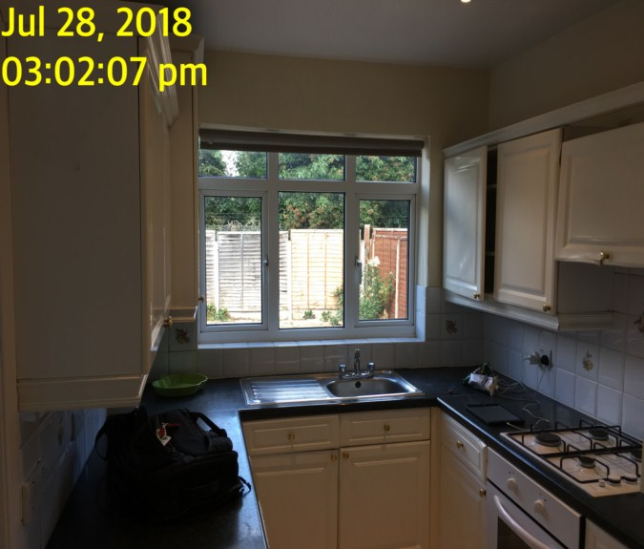 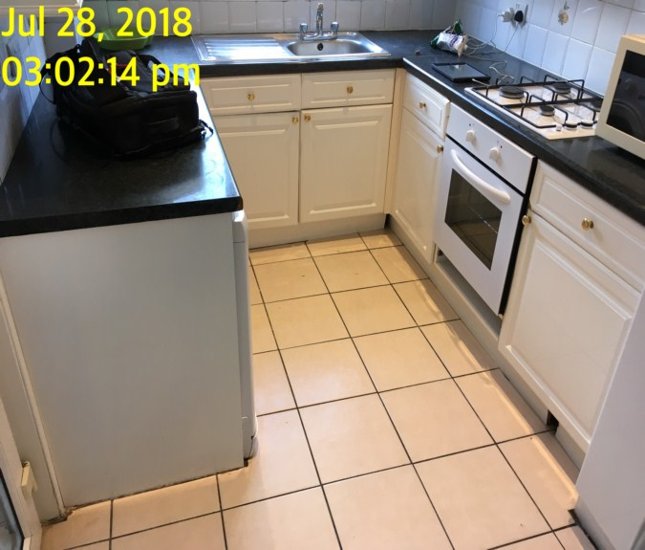

Kitchen Kitchen

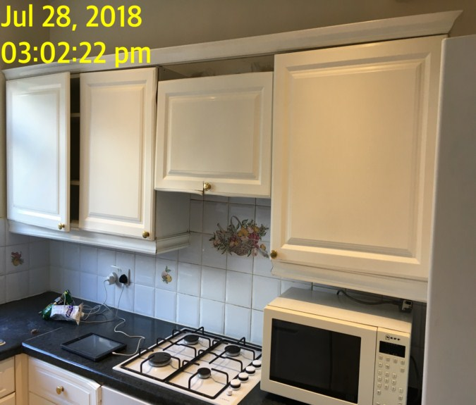 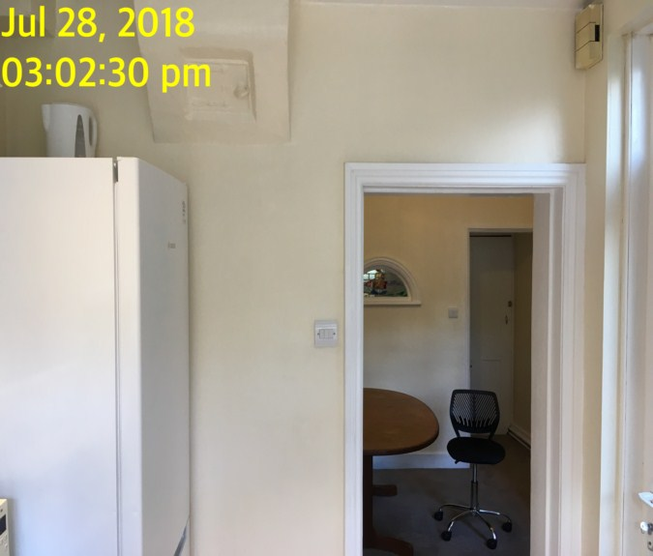

Kitchen Dishwasher

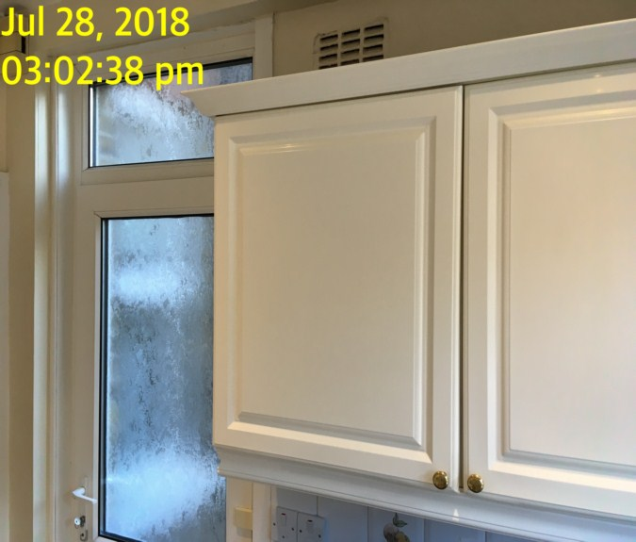 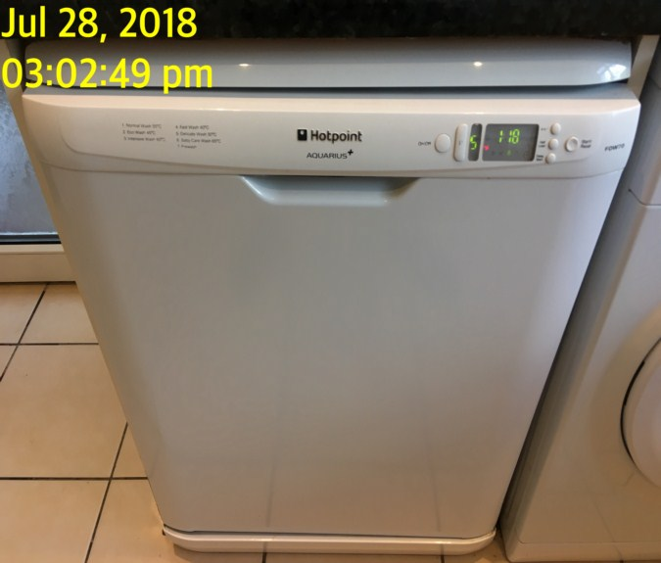

Dishwasher Dishwasher

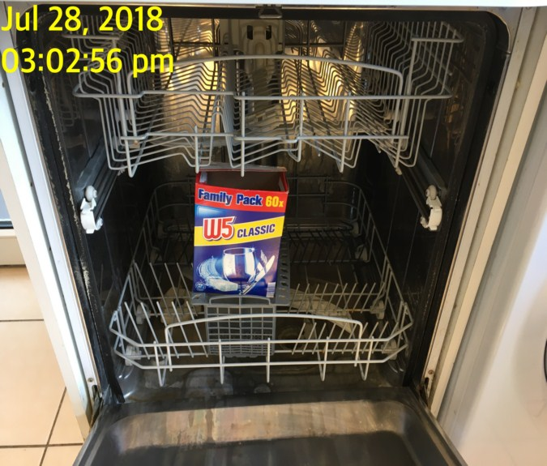 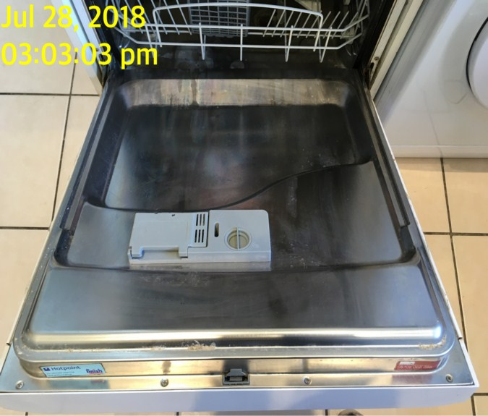

Washing machine Washing machine

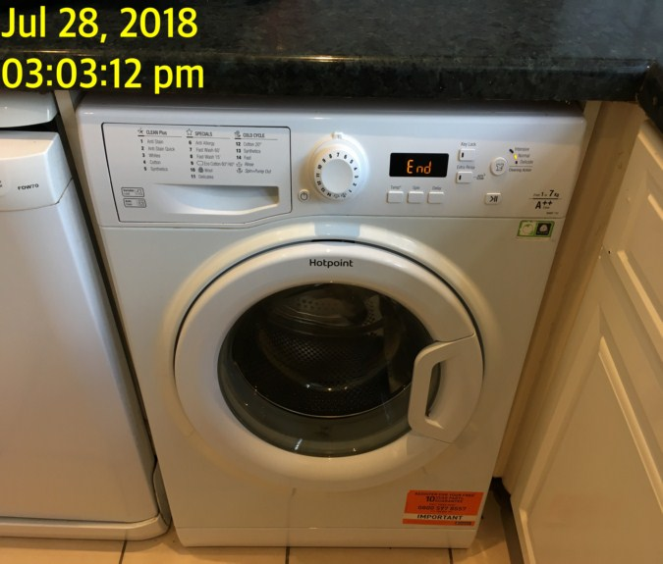 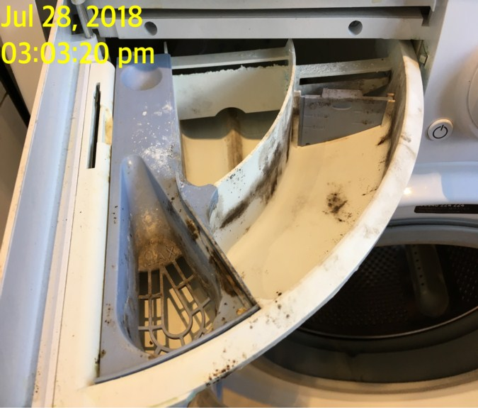

Washing machine Hob

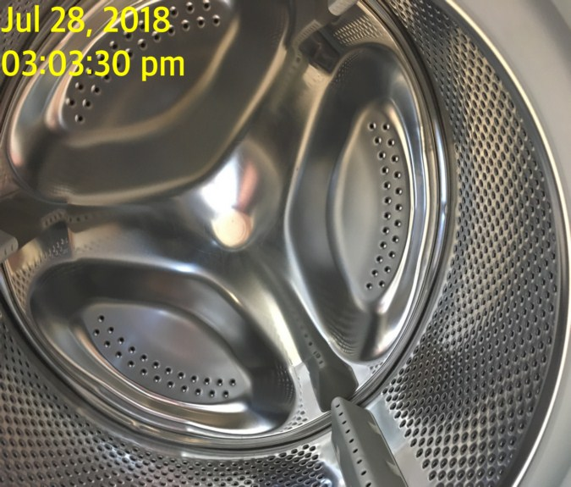 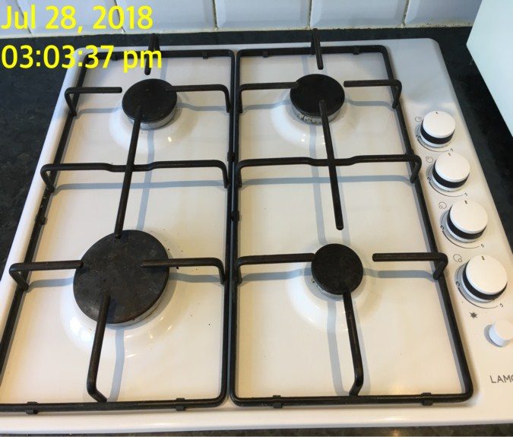

Extractor Oven

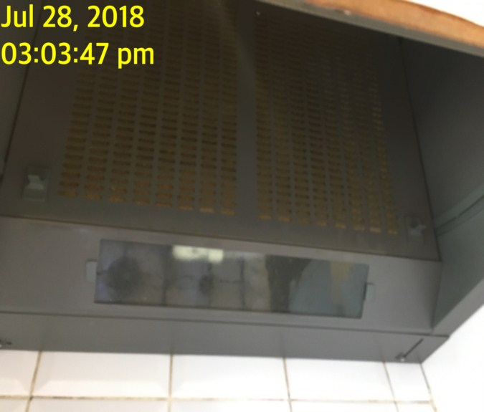 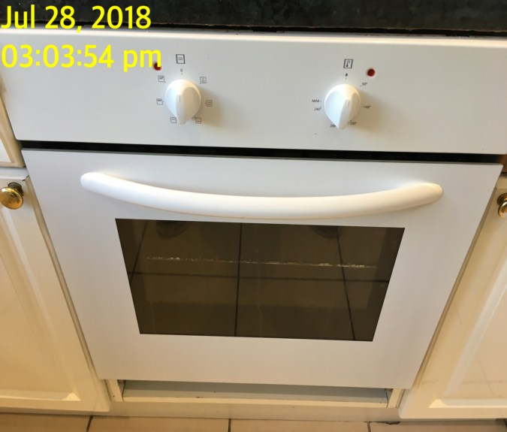

Oven Oven

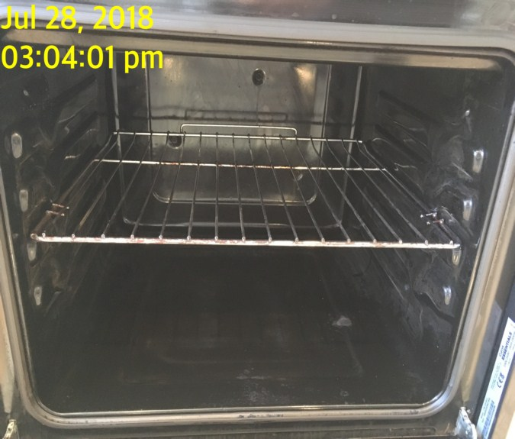 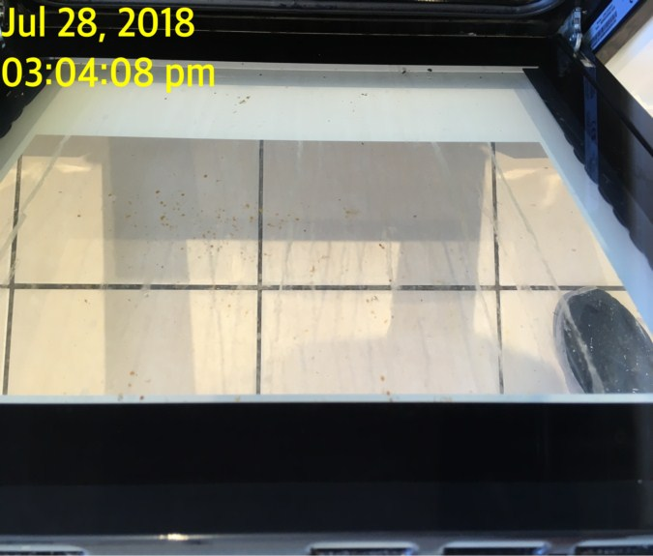

Microwave Microwave

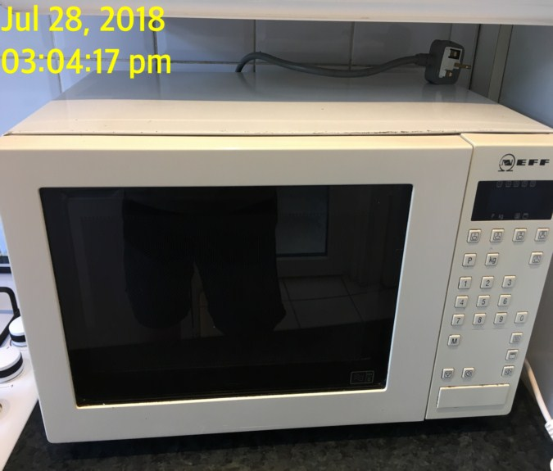 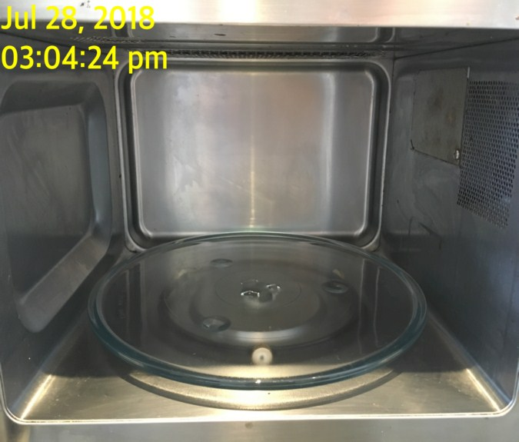

Fridge/ freezer Fridge/ freezer

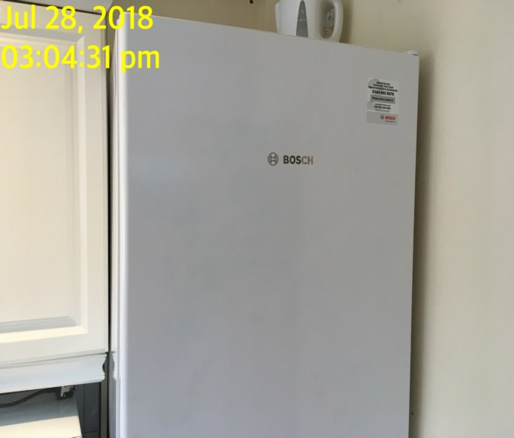 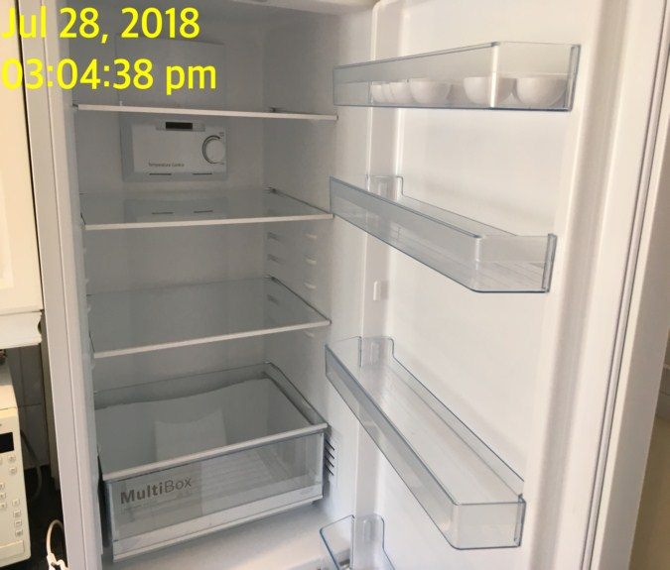

Fridge/ freezer

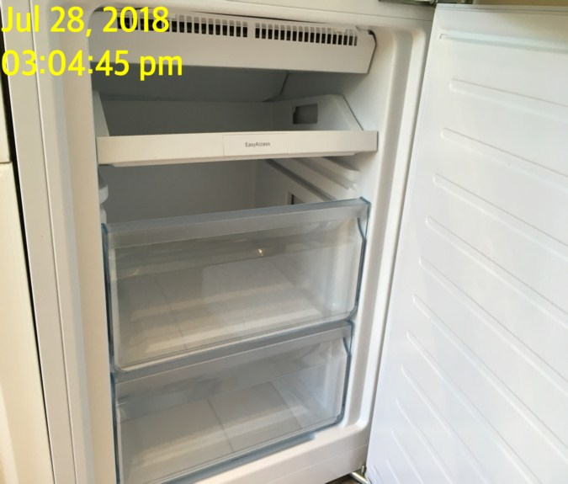**BEDROOM 1**

|  |  |  |  |
| --- | --- | --- | --- |
| **Door** | Exterior Door Frame  Wood painted white |  |  |
|  | Exterior Door  White painted wooden panelled surface  Chrome lever handles |  |  |
|  | Interior Door Frame  Wood painted white |  |  |
|  | Interior Door  White painted wooden panelled surface  Chrome lever handles | Over door hooks attached |  |

**BEDROOM 1**

|  |  |  |  |
| --- | --- | --- | --- |
| **Walls** | Textured wallpaper painted beige  Back wall – baton attached with 7 hooks | 1. Seams visible to the wallpaper throughout 2. Embedded screw at high level on the right 3. Back wall has 3 x screws embedded and 1 x to the left hand wall 4. Cobwebs to top corner |  |
| **Ceiling** | Painted white with matching coving |  |  |
| **Lights** | White plastic pendant with white plastic shade | 1. Intact 2. Tested and working |  |
| **Woodwork** | Skirting painted white | Scattered rubs/scuffs |  |

**BEDROOM 1**

|  |  |  |  |
| --- | --- | --- | --- |
| **Windows** | Pair of garden access doors double glazed in white UPVC casement and matching frame with opening transom above  3 x in-built lever handle fixtures, 2 x of them having in-built cylinder locks  ~~2~~ 1 x keys present | 1. 1 x hook to the right 2. UPVC is discoloured and patches throughout |  |
| **Curtains** | Cream fabric roller blind with silver metal beaded chain | 1. Tested and working 2. Not safety complaint 3. Few stains to fabric |  |
| **Flooring** | Fitted grey carpet | 1. Some minor furniture indentation |  |
| **Radiator** | Double panelled white metal radiator  Thermostatic valve to left |  |  |

**BEDROOM 1**

|  |  |  |  |
| --- | --- | --- | --- |
| **Wardrobe** | Freestanding mid wood effect laminate pair of doors with curved silver metal handles to each  Single shelf inside, chrome clothing rail | Odd scuff to interior |  |
| **Storage unit** | Mid wood storage unit  Single shelf  2 x single doored cupboards beneath with metal handles | 1. Slightly unstable, marked and scuffed all over      1. Back panel is loose |  |
| **Chest of drawers** | Mid wood effect chest of drawers with 6 x drawers | 1. Heavily worn to top |  |
| **Side unit** | Black wood effect black metal legs | 1. Scratched and marked      1. Now located in reception |  |

**BEDROOM 1**

|  |  |  |  |
| --- | --- | --- | --- |
| **Side table** | Cream with leather effect top side table with single door  Single shelf inside | Stains to top  Strip lifting to side |  |
| **Bed** | Double cream and floral base with black and white double mattress | 1. FFR label seen to mattress 2. Top is bubbled and shaded where accessible 3. Mattress appears to be slightly buckled to centre unable to fully inspect 4. Mattress protector is not clean so stuck to mattress |  |
| **Lamp** | Freestanding black metal plastic lamp | 1. Not tested |  |
| **Additional** | Wooden frame mirror |  |  |

Bedroom 1 Bedroom 1

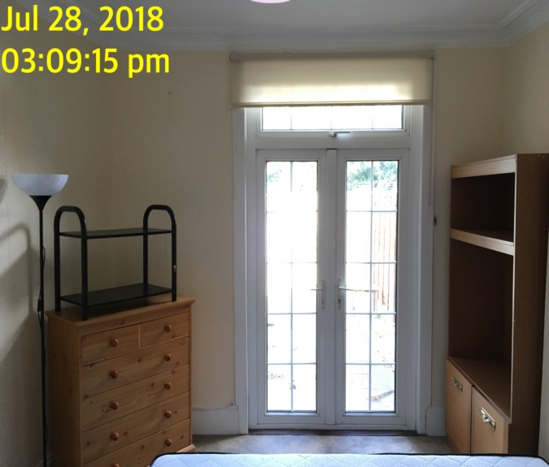 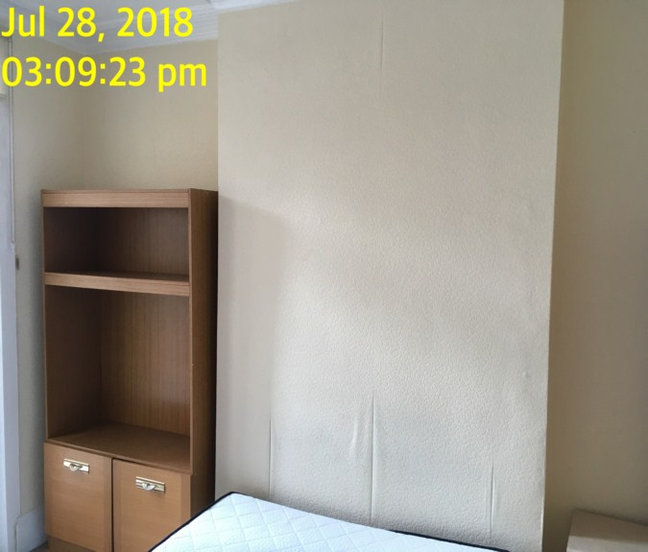

Bedroom 1 Bedroom 1

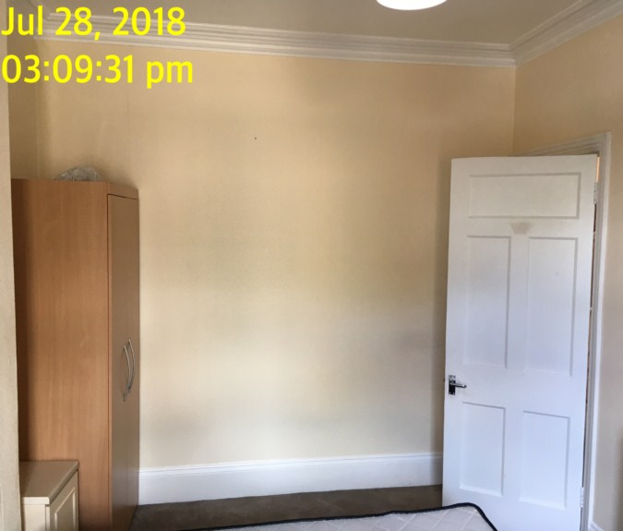 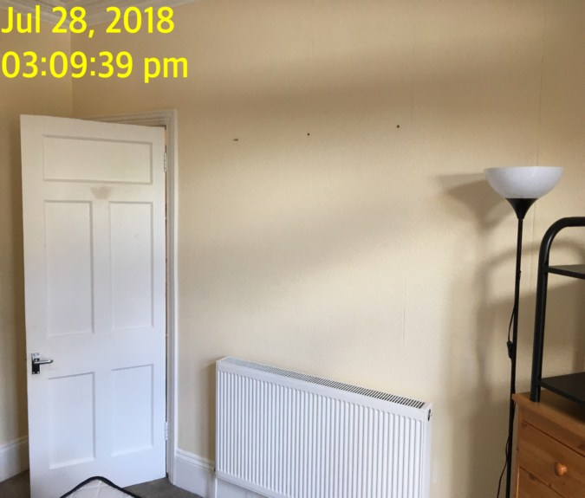

Bedroom 1

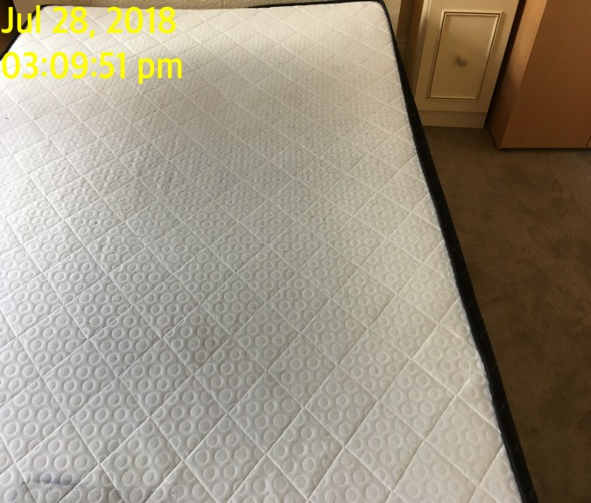**RECEPTION**

|  |  |  |  |
| --- | --- | --- | --- |
| **Door** | Exterior Door Frame  Wood painted white  Silver metal strip threshold |  |  |
|  | Exterior Door  White painted wooden panelled surface  Chrome lever handle |  |  |
|  | Interior Door Frame  Wood painted white |  |  |
|  | Interior Door  White painted wooden panelled surface  Chrome lever handle |  |  |

**RECEPTION**

|  |  |  |  |
| --- | --- | --- | --- |
| **Walls** | Painted beige | 1. Left hand wall has mismatching paintwork touch up to the upper level 2. 2 x fitment holes either side of the window |  |
| **Ceiling** | Painted white with matching coving |  |  |
| **Lights** | White metal bar with 3 x lamps to centre | 1. ~~All tested and~~ 1 x not working |  |
| **Woodwork** | Skirting painted white | Scattered rubs/scuffs |  |
| **Switches and sockets** | Range of light switches and mains outlets in white plastic | 1. ~~All intact~~ Telephone socket is loose |  |

**RECEPTION**

|  |  |  |  |
| --- | --- | --- | --- |
| **Windows** | Double glazed in white UPVC casement  3 x lockable lever handle fixtures in situ  Dark brown wood stained sill | 1. However no keys |  |
| **Curtains** | Pair of brown fabric curtains on white plastic track | 1. Moisture staining to right hand side lower edges 2. String pull mechanism to curtains tested and working –appears broken now in middle 3. Needs cleaning 4. No safety compliant |  |
| **Flooring** | Fitted brown carpet | 1. Needs cleaning |  |
| **Radiator** | Shaped white metal double panelled radiator | 1. Missing the right hand valve cap |  |

**RECEPTION**

|  |  |  |  |
| --- | --- | --- | --- |
| **Sofa** | 2 x double seater brown leather sofas  Each with pair of beige cushions and 5 x beige and grey scatter cushions    Double seater grey fabric upholstery  Additional sofa seen | 1. Left hand sofa is missing 1 x of the scatter cushion and has been replaced by small blue one 2. Grey fabric upholstery sofa has small amount of dust and dirt beneath seats 3. Small amount of staining to upholstery |  |
| **Side tables** | Nest of 3 x side tables in mid wood | 1. Mid centre some scratching and usage marking all over 2. One table is broken |  |
| **Coffee table** | Pale wood effect coffee table | 1. Chipping and marking to top 2. Bubbling to top 3. 1 x leg is taped. 1 x leg is loose |  |
| **~~Mattress~~** | ~~2 x Spare single mattresses,~~  ~~1 x beige and~~  ~~1 x blue~~ | 1. ~~Both in used condition~~ 2. ~~Some discolouration and staining~~ |  |
| **Speakers** | Logitech speakers subwoofer with single side speaker | Now located in utility cupboard |  |

**RECEPTION**

|  |  |  |  |
| --- | --- | --- | --- |
| **Router** | White metal Virgin media broadband router and black metal virgin media receiver box with remote control | Now located in hallway cupboard |  |
| **Lamp** | Freestanding lamp in black metal | 1. Tested and working |  |
| **Lamp** | Freestanding lamp in black metal with white paper shade | 1. Not tested – cannot access 2. Shade is heavily torn |  |
| **Additional** | TV unit , 1 x remote controls |  |  |

Reception Reception

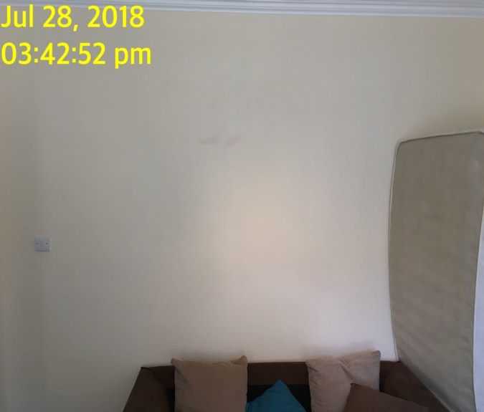 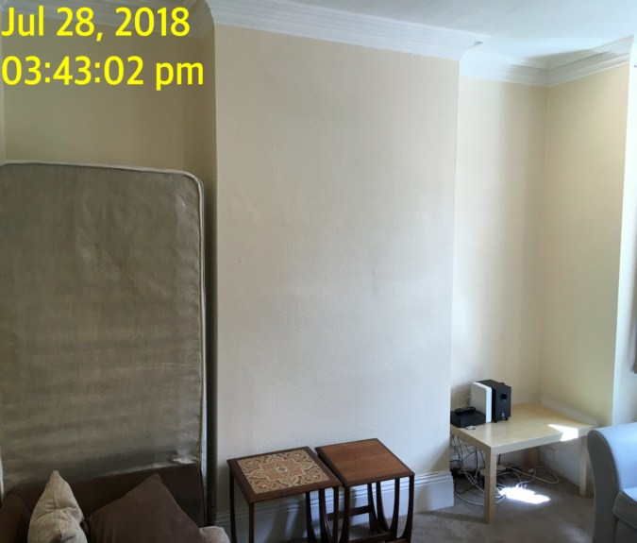

Reception Reception

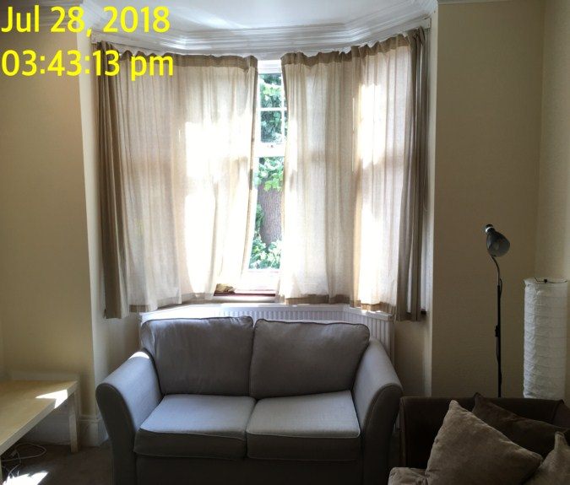 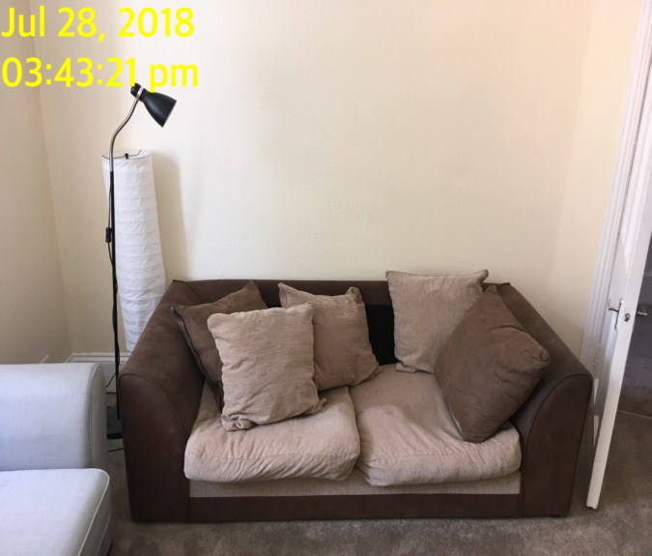

Reception Reception

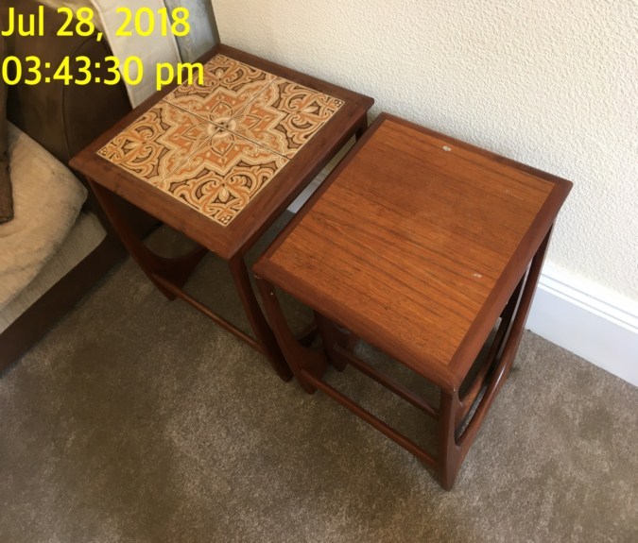 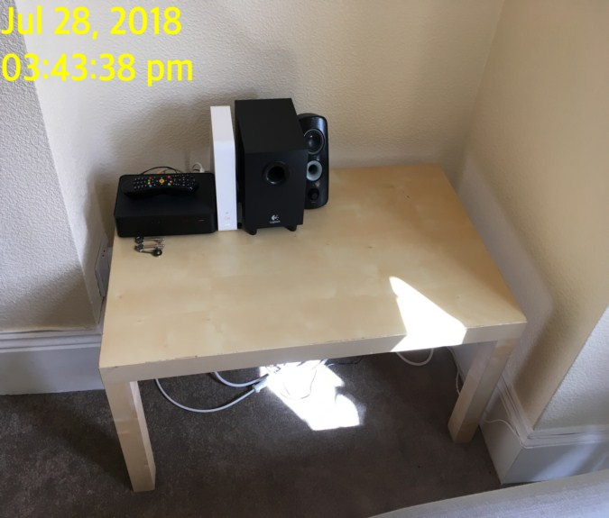

**STAIRS AND LANDING (ENTRANCE IS OPEN PLAN)**

|  |  |  |  |
| --- | --- | --- | --- |
| **Walls** | Painted magnolia | Scattered rubs/scuffs |  |
| **Ceiling** | Painted white  Ceiling hatch  Glass windows | 3 x glass shade missing |  |
| **Lights** | Brass metal cage style ceiling mounted light fitting with 3 x bulb lamp with clear glass shade | 1. 1 x bulb is missing 2. 1 x bulb not functioning 3. 1 x bulb is working |  |
| **Woodwork** | Skirting painted white  Handrail, newel post and banister all in wood painted white | 1. Odd rubs/scuffs  2. Light dust top of skirting |  |
| **Switches and sockets** | Range of light switches and mains white plastic | 1. All intact |  |

**STAIRS AND LANDING (entrance is open plan)**

|  |  |  |  |
| --- | --- | --- | --- |
| **Flooring** | Fitted brown carpet | 1. Hairs on carpet  2. Needs cleaning  3. Stain front of bathroom door |  |
| **Smoke alarm** | Ceiling mounted smoke alarm | 1. Tested and working 2. Green light seen 3. Date is too high to read |  |

Stairs and landing Stairs and landing

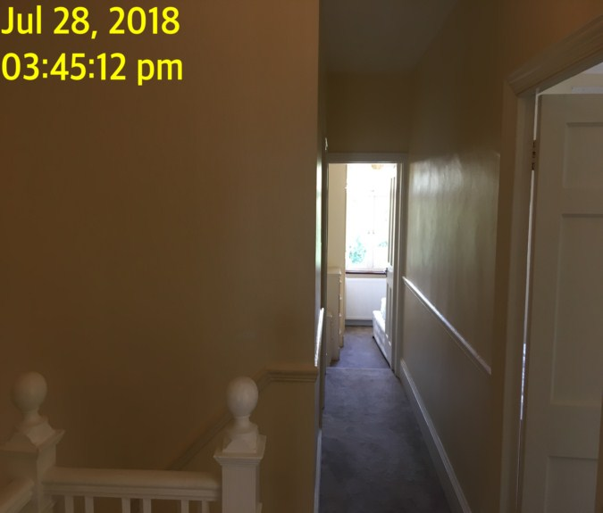 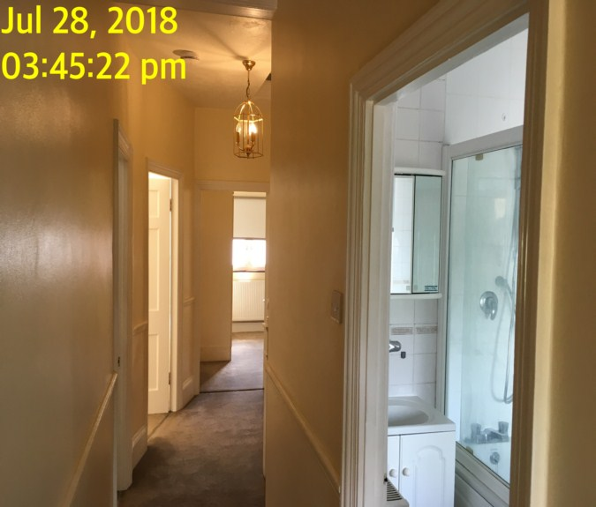

Stairs and landing Stairs and landing

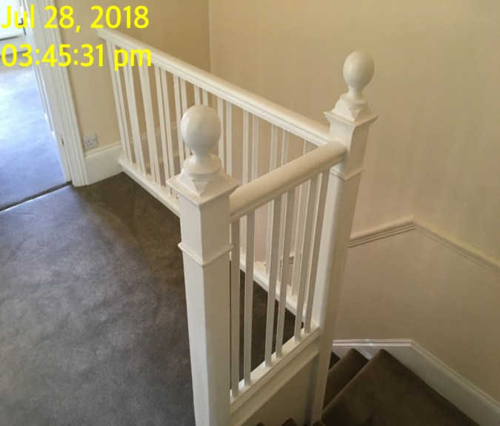 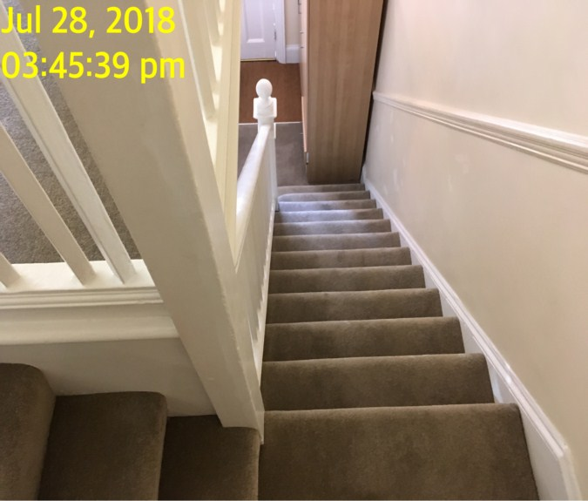

**BATHROOM**

|  |  |  |  |
| --- | --- | --- | --- |
| **Door** | Exterior Door Frame  Wood painted white  Silver metal strip threshold |  |  |
|  | Exterior Door  White painted wooden panelled surface  Chrome lever handle |  |  |
|  | Interior Door Frame  Wood painted white |  |  |
|  | Interior Door  White painted wooden panelled surface  Chrome lever handle |  |  |

**BATHROOM**

|  |  |  |  |
| --- | --- | --- | --- |
| **Walls** | White tiling throughout  Gold decorative pattern to tiling at the back, left wall as well to above the toilet on facing wall | 1. Grouting is discoloured throughout 2. Mould visible 3. Stress cracks above blind under bath control taps |  |
| **Ceiling** | Painted white |  |  |
| **Lights** | 3 x ceiling mounted down lights | 1. All tested and working |  |
| **Windows** | Double glazed obscured glass white UPVC casement with matching lockable lever handle fixture | 1. No key in situ |  |
| **Curtains** | White fabric roller blind  White plastic beaded chain | 1. ~~Tested and~~ Not working 2. Not safety complaint 3. Fitment holes either side of blind upper level |  |

**BATHROOM**

|  |  |  |  |
| --- | --- | --- | --- |
| **Flooring** | Beige tiling | 1. 3 x tiles at base of toilet cracked 2. 1 x tile in front of door crack slightly      1. Dirt, dust, hairs, needs cleaning 2. Discolouration to grout |  |
| **Radiator** | Double panelled white metal radiator | Rusting to top panel and bottom |  |
| **Sink** | White acrylic sink with chrome mixer tap  Push plug and overflow | 1. Some heavily cracked appearance around the mixer tap 2. Not clean 3. Tested and working 4. Spider crack exterior bowl 5. 2 x chip to edges of sink |  |
| **Toilet** | White ceramic lid and seat with  White laminate unit behind  Double chrome flush button | 1. Tested and working  2. Very dirty  3. Stained under rim and under water |  |

**BATHROOM**

|  |  |  |  |
| --- | --- | --- | --- |
| **Bath** | White steel bath with white laminate side panel  Chrome mixer tap  Wall mounted shower fitting including:  Riser, showerhead, flex hose and dial, waste and overflow to match and black rubber plug  Shower gauge is white plastic and metal with fixed clear glass panel and 2 x sliding panels | 1. Beaded chain with plug has snapped 2. Tap and shower not tested ~~and working~~ 3. Heavy mildew discolouration around the edge 4. 1 x white plastic white fitting top of door is missing 5. Sliding panels is heavily discoloured 6. Glass is misted and water marked 7. Needs cleaning 8. Water damage bottom right hand side panel 9. Shower head is different from CI 10. Additional shower head seen behind WC in plastic |  |
| **Towel rail** | 1 x wall mounted towel rail | Tiles are cracked to left hand side around bracketTowel rail is loose |  |
| **Cabinets Under sink** | Pair of white laminate doors1 x shelf insideWall mounted white laminate cabinet with 3 x mirror fronted doorsSingle light bulbInside with 4 x glass shelves | Heavily chipped to front of the middle and base shelf – not cleanLight in mirrored cabinet above is not functioningPull string is missing acornAppears to be missing some shelf to insideGrubby and discoloured inside 6. Silvering to mirror  7. Mirror not clean  8. Needs cleaning |  |

**BATHROOM**

|  |  |  |  |
| --- | --- | --- | --- |
| **~~Storage unit~~** | ~~Freestanding grey plastic storage unit with 4 x clear plastic baskets~~ | 1. ~~Paint spotted and in use~~ |  |
| **Mirror** | 1 x wall mounted small circular mirror |  |  |
| **Toilet roll holder** | 1 x chrome wall mounted toilet roll holder |  |  |
| **~~Picture frame~~** | ~~Fixture with small picture photographs Dolphins in blue plastic frame~~ |  |  |
| **Pedal bin** | Cylinder silver metal bin with black plastic interior | 1. Tested and working |  |
| **Toilet brush** | White plastic toilet brush | In use |  |
| **~~Plunger~~** | ~~Black rubber and white plastic plunger~~ |  |  |
| **Additional** | 2 x shower tidy  vent |  |  |

Bathroom Bathroom

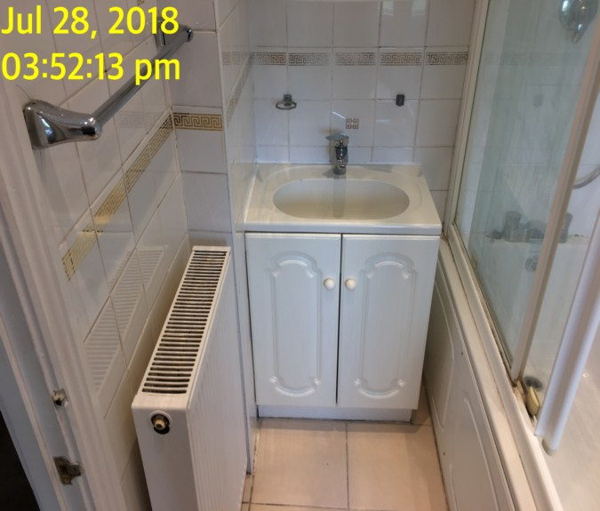 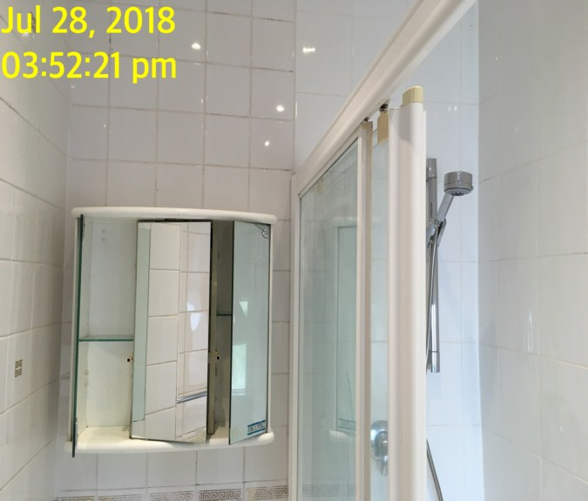

Bathroom Bathroom

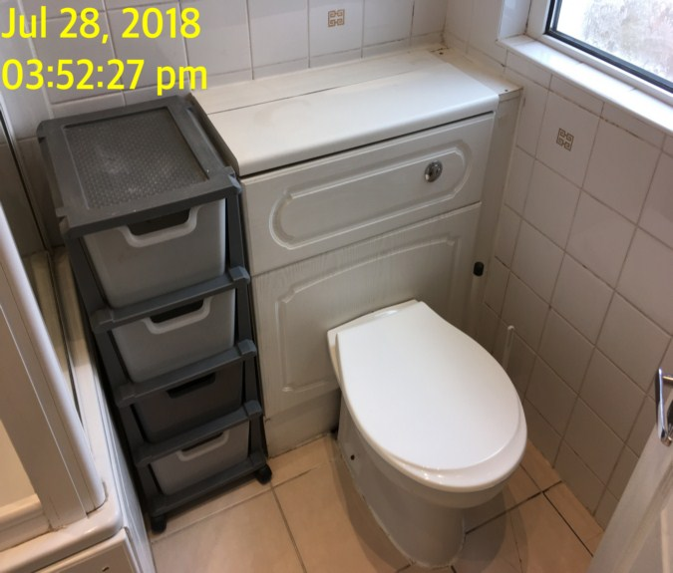 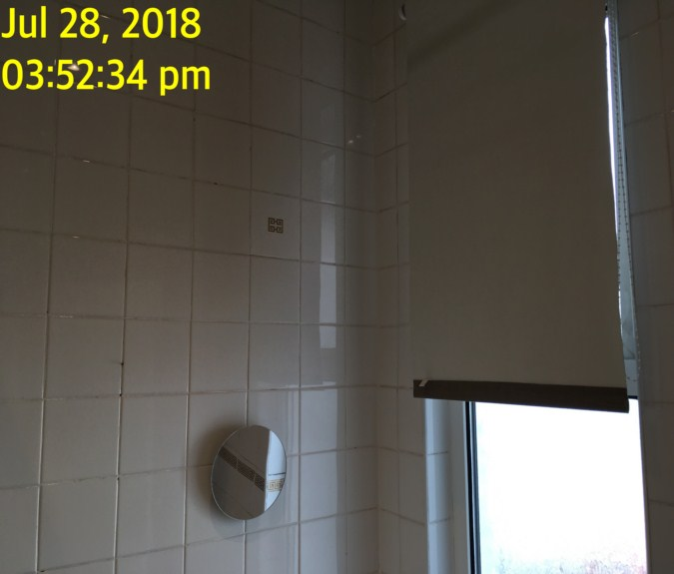

Bathroom Bathroom

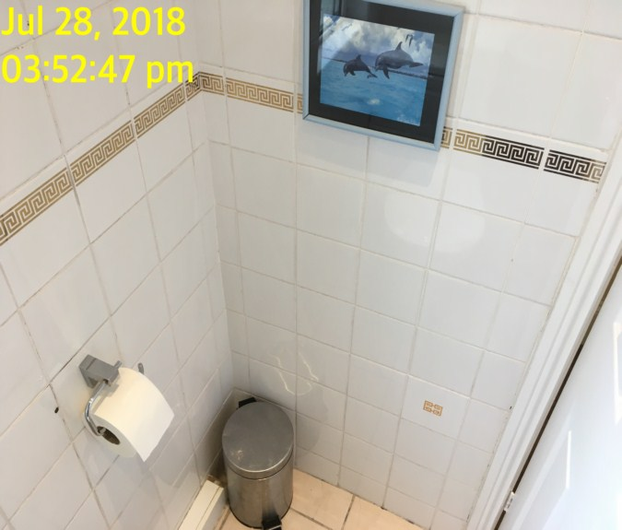 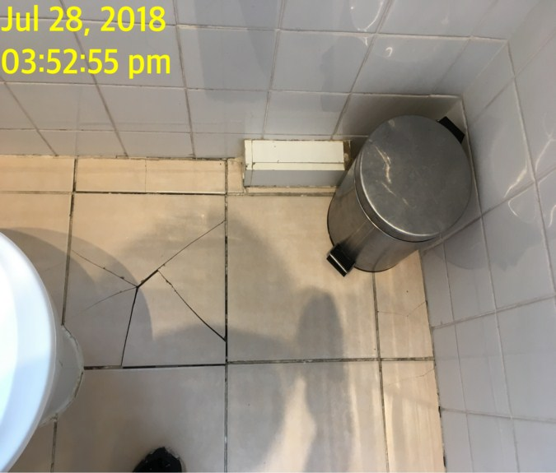

Bathroom

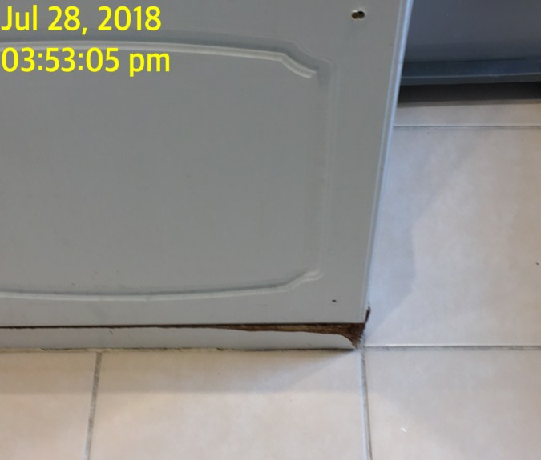

**BEDROOM 2**

|  |  |  |  |
| --- | --- | --- | --- |
| **Door** | Exterior Door Frame  Wood painted white |  |  |
|  | Exterior Door  White painted wooden panelled surface  Chrome lever handle  Removable set of chrome wire hooks to top edge |  |  |
|  | Interior Door Frame  Wood painted white |  |  |
|  | Interior Door  White painted wooden panelled surface  Chrome lever handle |  |  |

**BEDROOM 2**

|  |  |  |  |
| --- | --- | --- | --- |
| **Walls** | Painted magnolia with textured wallpaper | 1. Large metal screw to back wall 2. Small nail to right hand wall 3. Scattered rubs/scuffs |  |
| **Ceiling** | Painted white |  |  |
| **Lights** | White plastic ceiling mounted pendant in yellow curved shade | 1. Tested and working |  |
| **Woodwork** | Skirting painted white | 1. ~~Woodwork beneath entrance appears to have Looks newly fitted over fixing partially painted over beneath the door~~   Scattered rubs/scuffs |  |
| **Switches and sockets** | Range of mains outlets and light switches in white plastic | 1. All intact |  |

**BEDROOM 2**

|  |  |  |  |
| --- | --- | --- | --- |
| **Windows** | Double glazed white UPVC framed with 3 x built-in lockable lever handle fixtures to match | 1. 1 x Key~~s~~ in situ 2. Left hand side lever small section is missing |  |
| **Curtains** | Grey fabric roller bind  White plastic beaded chain | 1. Tested and working 2. Not safety complaint |  |
| **Flooring** | Fitted grey carpet | Needs further clean |  |
| **Radiator** | Double panelled white metal radiator |  |  |
| **Mirror** | Wall mounted vertical bevelled edge mirror |  |  |
| **Shelf** | Wall mounted shelf painted to match walls with 4 x brackets |  |  |

**BEDROOM 2**

|  |  |  |  |
| --- | --- | --- | --- |
| **Bed** | Single off-white and white with floral pattern and matching mattress | 1. FFR label seen 2. Dirty/ body fluids to mattress      1. Stains to divan |  |
| **Chest of drawers** | Cream laminate chest of drawers comprising 4 x drawers  Leather effect grey top | 1. Top is marked 2. Light stain to interior |  |
| **Side table** | Cream laminate side table with single door  Leather effect grey top | 1. Some flaking to laminate on the side |  |
| **Mirror** | Wall mounted vertical mirror, framed with bevelled edge |  |  |
| **Wardrobe** | Cream laminate double doored wardrobe unit with 2 x brass metal clothing rails inside  Double doored main unit 2 x small chrome hanging bars to interior | 1. Few scuff to interior walls |  |

Bedroom 2 Bedroom 2

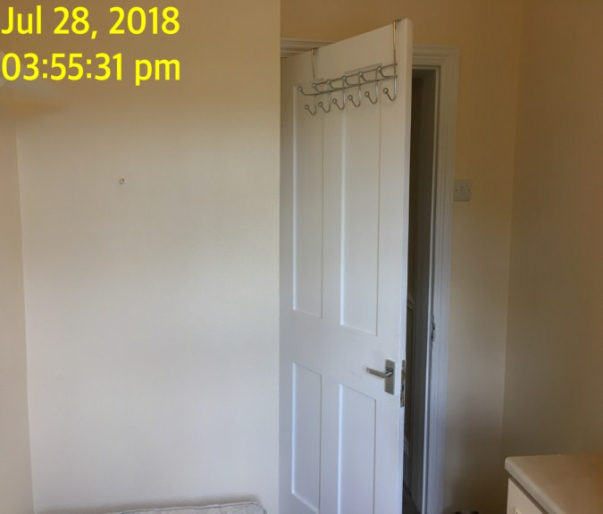 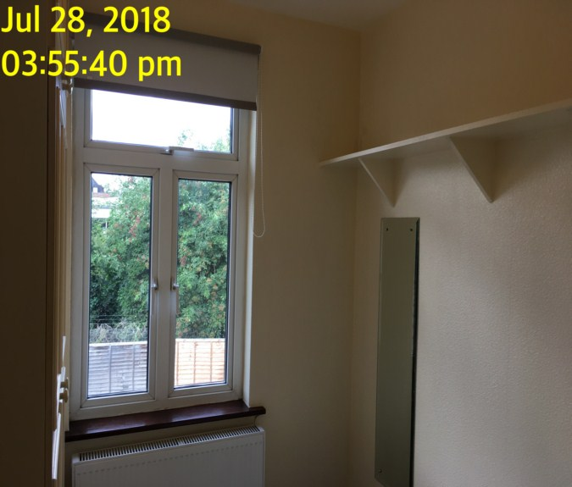

Bedroom 2 Bedroom 2

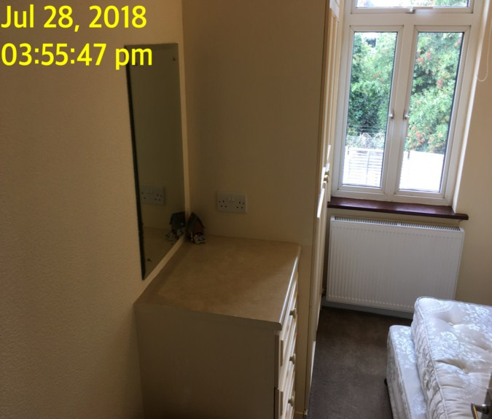 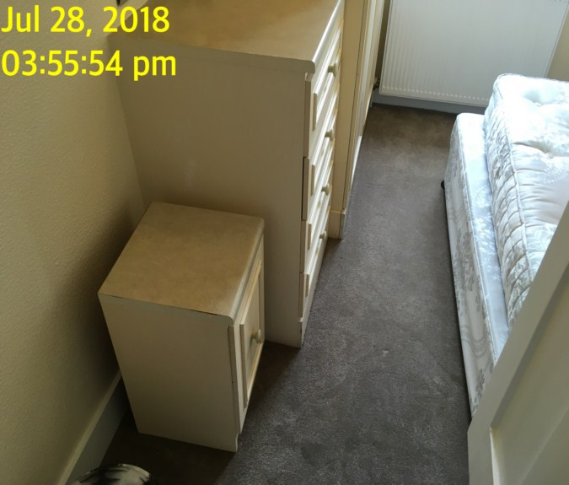

Bedroom 2

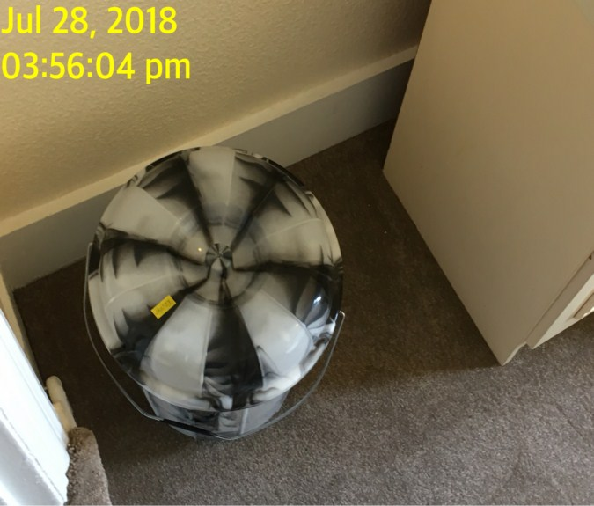

**BEDROOM 3**

|  |  |  |  |
| --- | --- | --- | --- |
| **Door** | Exterior Door Frame  Wood painted white  Silver metal strip threshold |  |  |
|  | Exterior Door  White painted wooden panel surface  Chrome lever handle |  |  |
|  | Interior Door Frame  Wood painted white |  |  |
|  | Interior Door  White painted wooden panel surface  Chrome lever handle | 2 x pin holes under handle |  |

**BEDROOM 3**

|  |  |  |  |
| --- | --- | --- | --- |
| **Walls** | Painted magnolia with textured wallpaper | Odd rubs/scuff |  |
| **Ceiling** | Painted white |  |  |
| **Lights** | Chrome bar with 4 x lamps attached | 1. ~~All tested and working~~   1 x not working  1 x bulb missing |  |
| **Woodwork** | Skirting painted white | Scattered rubs/scuff |  |
| **Switches and sockets** | Range of light switch and mains outlets in white plastic | 1. All intact |  |

**BEDROOM 3**

|  |  |  |  |
| --- | --- | --- | --- |
| **Windows** | Double glazed in white UPVC casement with 3 x lockable lever handle fixtures in situ  Dark brown stoned wooden sill | 1. No keys |  |
| **Curtains** | White and grey fabric roller blind with white plastic beaded chain | 1. Tested and working 2. Not safety complaint      1. 7 x pin holes above blind |  |
| **Flooring** | Fitted grey carpet | 1. Odd pressure marks  2. Final clean required |  |
| **Radiator** | Double panelled white metal radiator | 1. Both of the valve caps are missing |  |
| **Bedside units** | Cream laminate bedside units  Each single doored with leather effect top and brass effect handles | 1. Grubby and in use to interior |  |

**BEDROOM 3**

|  |  |  |  |
| --- | --- | --- | --- |
| **Wardrobe unit** | Cream laminate comprising various cupboards left to right  Left is double door main wardrobe unit with 2 x brass metal clothing rails  Double door over compartment containing some miscellaneous household items  3 x overhead double doored compartment and low level double doored compartment containing 2 x shelves, in-built mirror and 5 small side shelves  Unit 3: Double doored main wardrobe compartment containing 2 x shelves, brass metal clothing rail, mirror to the inside of right hand side door, small hanging inside of left  Double door overhead unit with loose handles | Few scuff to interior cupboards  Unable to inspect too high, not sure of items in interior  1 x door pull is detached  Frame bottom right hand side is detached |  |
| **Bed** | Double ~~off-white and white divan base with matching mattress~~ white metal bed and base with mattress | 1. ~~FFR label seen~~ Stained 2. Secured with tap to middle support |  |

Bedroom 3 Bedroom 3

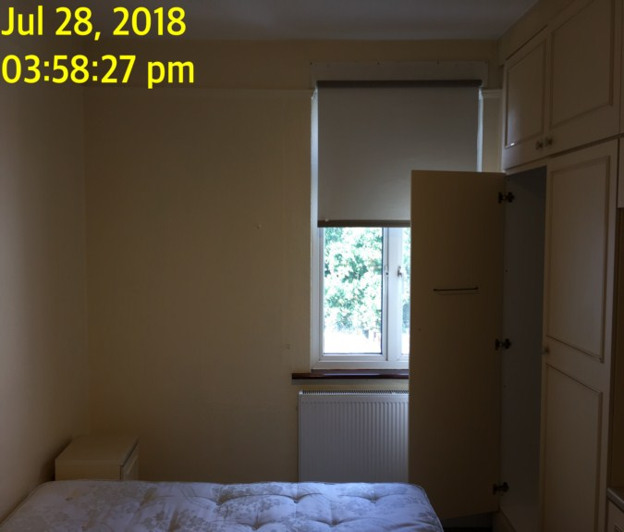 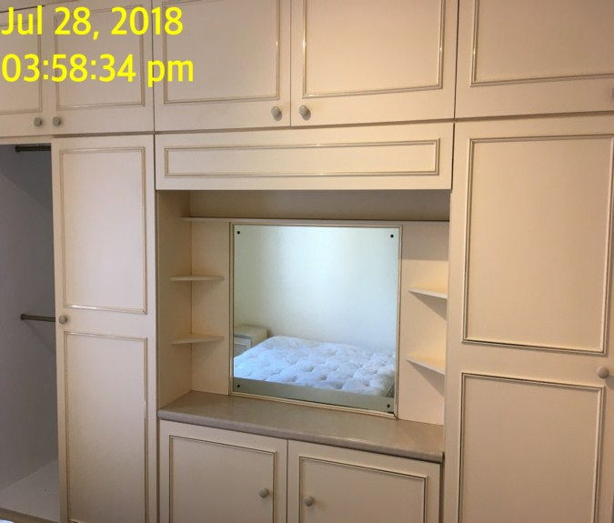

Bedroom 3

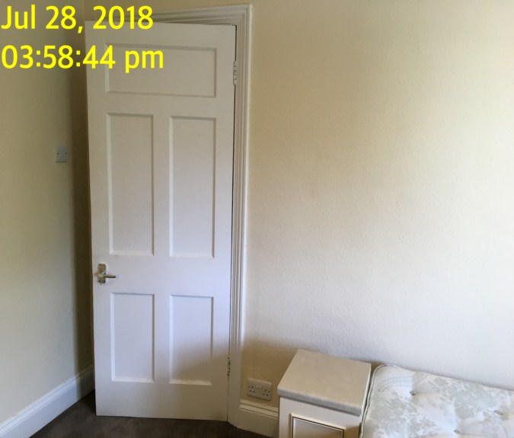

**BEDROOM 4**

|  |  |  |  |
| --- | --- | --- | --- |
| **Door** | Exterior Door Frame  Wood painted white  Silver metal strip threshold |  |  |
|  | Exterior Door  White painted wooden panel surface  Chrome lever handle |  |  |
|  | Interior Door Frame  Wood painted white |  |  |
|  | Interior Door  White painted wooden panel surface  Chrome lever handle |  |  |

**BEDROOM 4**

|  |  |  |  |
| --- | --- | --- | --- |
| **Walls** | Painted magnolia with textured wallpaper | Scattered rubs/scuff |  |
| **Ceiling** | Painted white |  |  |
| **Lights** | Ceiling mounted light fitting with 3 x bulb points in frosted shade | 1. Tested and working 2. ~~2 x of the bulbs not functioning~~ |  |
| **Woodwork** | Skirting painted white | Scattered rubs/scuff |  |
| **Windows** | Double glazed in white UPVC casement with 3 x lockable lever handle fixtures in situ  Dark brown stoned wooden sill | 1. No keys |  |

**BEDROOM 4**

|  |  |  |  |
| --- | --- | --- | --- |
| **Curtains** | White fabric net curtains and white rubber cord | Needs further clean |  |
| **Additional** | 2 x cream /grey drapes |  |  |
| **Flooring** | Fitted grey carpet | Odd hairs to floor |  |
| **Radiator** | Shaped double panelled white metal radiator | 1. Missing the left hand thermostatic valve |  |
| **Mirror** | 2 x bevelled edge mirror mounted to left hand wall |  |  |
| **Chest of drawers** | Cream laminate chest of drawers with 3 x drawers and grey handles |  |  |

**BEDROOM 4**

|  |  |  |  |
| --- | --- | --- | --- |
| **Bedside units** | Cream laminate bedside units  Each single doored with leather effect top and brass effect handles | Odd scuff to unit  Strip hanging to side |  |
| **Bed** | White and blue chequered pattern bed base with matching mattress | 1. Mattress has some minor stains to top 2. Torn to base 3. Fluffing to fabric 4. In use |  |
| **Wardrobe** | In-built wardrobe left to right  Double doored main wardrobe compartment with chrome brass clothing rail inside, 2 x hanging rail to inside of door  Double doored matching overhead compartment above  Unit 2: Double doored main wardrobe compartment contains 4 x side shelves, 1 x main shelf, 2 x small brass clothing rails  Double doored compartment above  Unit 3: Double main wardrobe with 2 x white shelves, brass metal clothing rail  Double doored compartment above  Shelves to inside of main area | Piece of strip missing to front of shelf |  |

**BEDROOM 4**

|  |  |  |  |
| --- | --- | --- | --- |
| **Chair** | Ikea chair with flexible mid wood and frame white fabric upholstery | Few stains |  |
| **~~Lamp~~** | ~~Freestanding white plastic and metal lamp~~ | 1. ~~Not tested~~ |  |

Bedroom 4 Bedroom 4

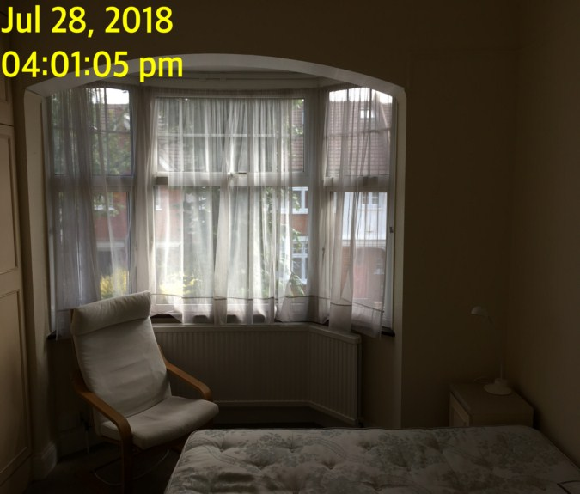 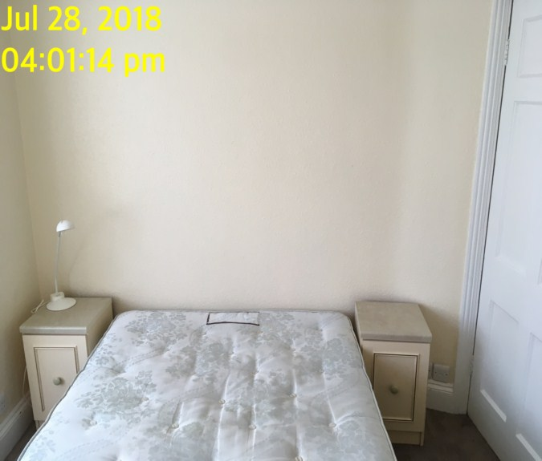

Bedroom 4 Bedroom 4

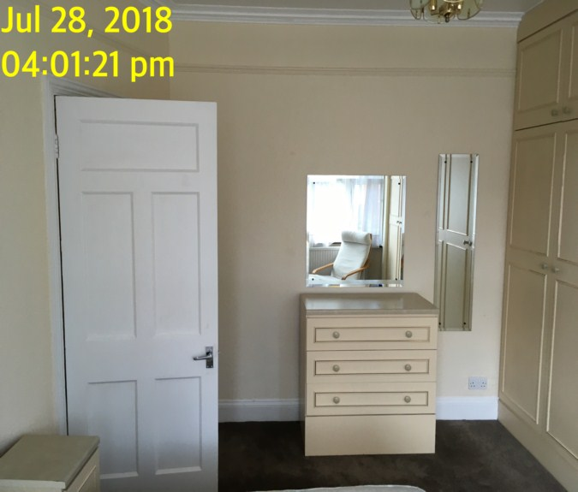 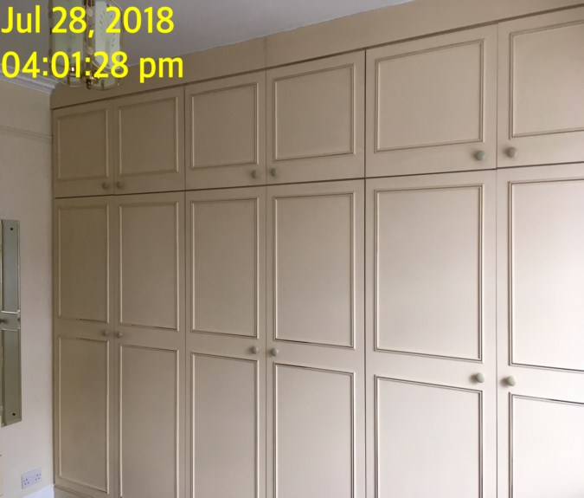**BEDROOM 5**

|  |  |  |  |
| --- | --- | --- | --- |
| **Door** | Exterior Door Frame  Wood painted white  Silver metal strip threshold |  |  |
|  | Exterior Door  White painted wooden panel surface  Chrome lever handle  Chrome Yale cylinder lock to exterior | 1. 1 x key in situ |  |
|  | Interior Door Frame  Wood painted white |  |  |
|  | Interior Door  White painted wooden panel surface  Chrome lever handle  Chrome Yale lock box to interior | Cracking to panels upper level |  |

**BEDROOM 5**

|  |  |  |  |
| --- | --- | --- | --- |
| **Walls** | Painted magnolia with textured wallpaper | Odd stain low level of right hand side |  |
| **Ceiling** | Painted white |  |  |
| **Lights** | White plastic pendant fitting without shade | 1. Tested and working |  |
| **Woodwork** | Skirting painted white | Scattered rubs |  |
| **Switches and sockets** | Range of light switch white plastic |  |  |
| **Windows** | Double glazed in white UPVC frame with 3 x opening panels, 3 x matching lockable lever handle fixtures | 1. No keys in situ 2. Right hand side handle loose - screw missing |  |

**BEDROOM 5**

|  |  |  |  |
| --- | --- | --- | --- |
| **Curtains** | White fabric net curtains and white rubber cord | Not working |  |
| **Flooring** | Fitted grey carpet | Hairs on floor  Needs further clean |  |
| **Radiator** | Double panelled white metal radiator | 1. Missing the left hand thermostatic cap   2. Right hand side cap detached now on window sill |  |
| **Mirror** | 2 x wall mounted vertical bevelled edge mirrors |  |  |
| **Wardrobe** | Cream laminate double doored wardrobe contains brass clothing rail  Double doored overhead compartment above |  |  |

**BEDROOM 5**

|  |  |  |  |
| --- | --- | --- | --- |
| **Chest of drawers** | Cream laminate chest of drawers with 4 x drawers  Grey plastic handles and grey leather effect top | 1. Leather effect top is paint marked |  |
| **~~Chair~~** | ~~Grey plastic and mid wood effect chair~~ | 1. ~~Chipped and marked to edges and corners~~ |  |
| **Additional** | Clothes, airer, painting of a grill |  |  |

Bedroom 5 Bedroom 5

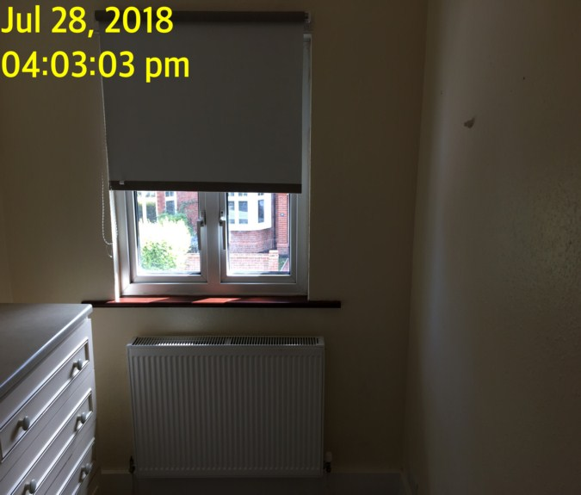 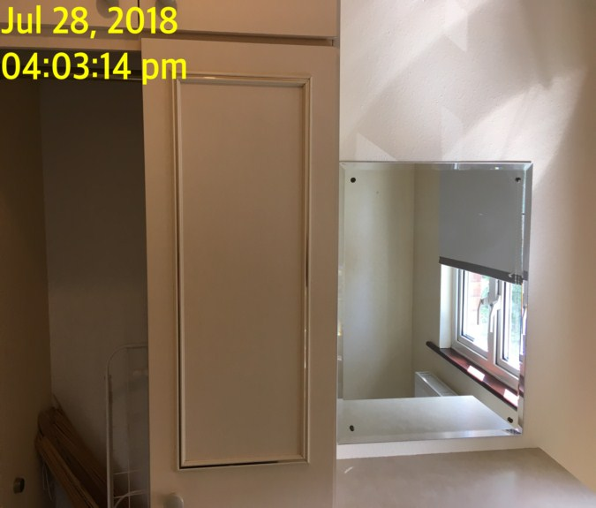

Bedroom 5 Bedroom 5

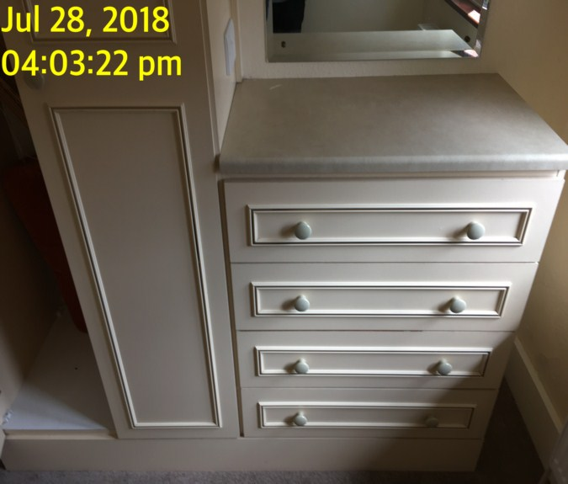 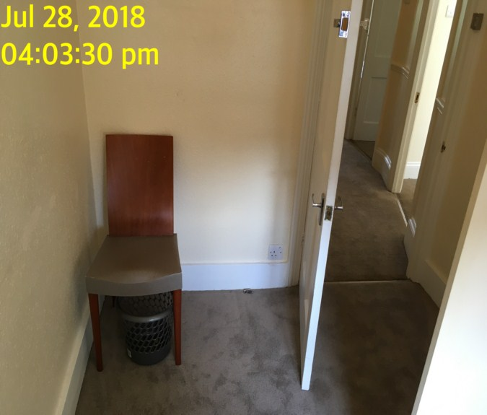

**GARDEN**

|  |  |  |  |
| --- | --- | --- | --- |
| **Borders** | Left, right and facing border are wooden fencing  Back wall is exposed brick work of the house  Walls painted white outside of kitchen  ~~White wooden~~ gate to far end | 1. ~~All weathered and discoloured~~ 2. Gate in ~~poor~~ out door condition 3. ~~Fence panels are all different colours~~   4. Pad lock on gate  5. facing lights hanging on fence |  |
| **Ground** | Part Patio paving ~~throughout~~ different sizes  Part white pebbles | 1. Weed growth 2. Weathering 3. Discolouration throughout due to age |  |
| **Light** | Single wall mounted external light | 1. Tested and working |  |
| **Over head halogens** | 2 x Black framed halogen light fitments | ~~Working order~~ Not tested |  |
| **Rose bush** | 1 Rose bush to far-right corner | ~~Fair~~ Poor order |  |
| **Misc items** | Varios bits of rubbish and metal left in garden |  |  |
| **Additional** | Plant pots, chairs, BBQ set, garden hose, 3 different tables |  |  |

Garden Garden

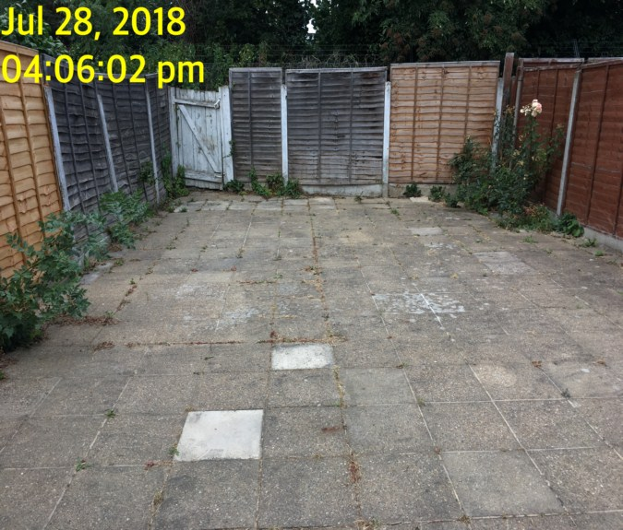 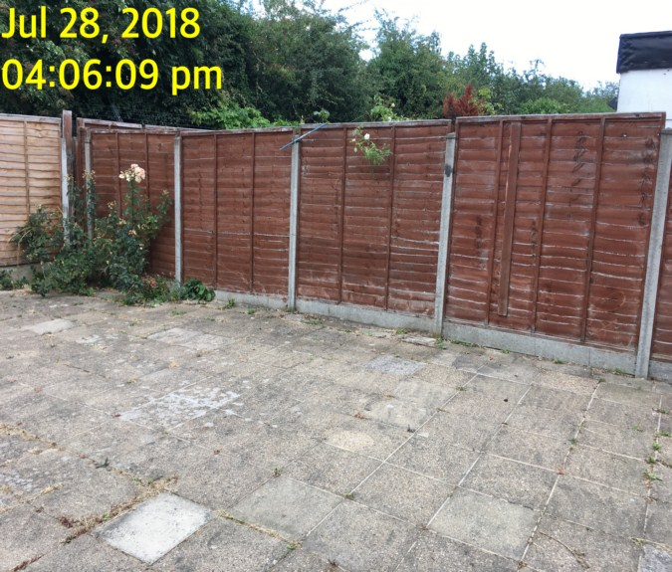

Garden Garden

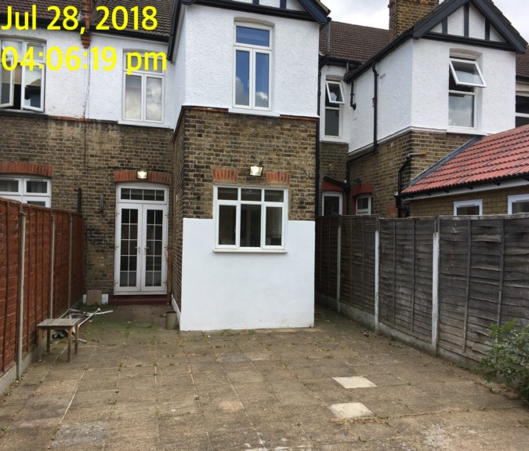 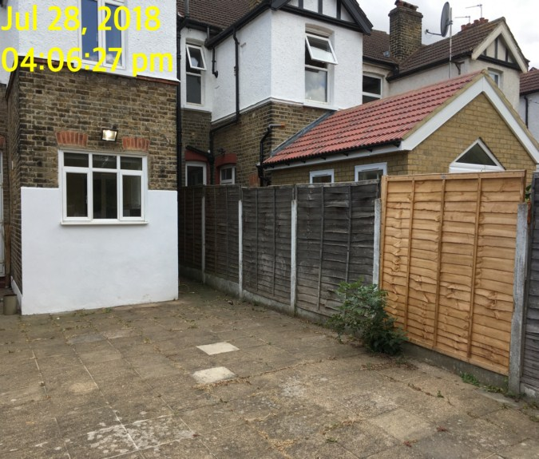

Garden

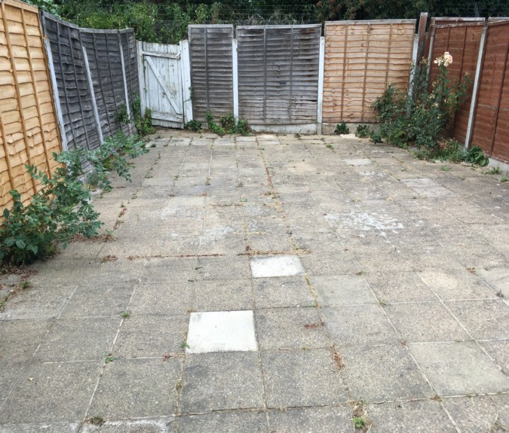

# DECLARATION AT CHECK IN

This inventory has been examined and, subject to marginal comments found to be correct.

## On behalf of the landlord

on behalf of the tenant _____

commencement of tenancy **______**

## **N.B**

This inventory is correct to the best of our knowledge but advise you to examine its contents prior to signing, as we can not be held responsible for any errors or omissions. Descriptions are for identification purposes only.

The relevant utility companies must check all meter readings, as we can not be held responsible for any discrepancies

**Please ensure that all items listed in this inventory are in the same location at the end of the tenancy.**

**ADDITIONAL AMENDMENTS**

|  |  |  |
| --- | --- | --- |
| DATE | DESCRIPTION OF CHANGES | AGENTS/LANDLORD SIGNATURE |
|  |  |  |
|  |  |  |
|  |  |  |
|  |  |  |
|  |  |  |
|  |  |  |
|  |  |  |
|  |  |  |
|  |  |  |

WHEN ADDITIONS/AMENDMENTS ARE MADE BY THE LANDLORD, TENANT OR AGENT THE RELATIVE PARTIES MUST BE INFORMED

**GENERAL COMMENT**

It should be noted that it is not the responsibility of the Inventory Clerk to open, unpack, empty or itemise items stored in carrier bags

or other containers  unless it is made specifically clear they are the property of the Landlord.

|  |
| --- |
| **CHECK OUT REPORT OF CONDITION AT: DATE:** 20/01/2021 |

|  |  |
| --- | --- |
| **PROPERTY ADDRESS:** | 21 Waldegrave Rd  Ealing  W5 3HT |
| **CLIENT:** | Thorgills |
| **CONTACT:** | Kat Felton |

|  |  |  |
| --- | --- | --- |
| **ELECTRIC** | **GAS** | **WATER** |
| **METER NUMBER:**  ZO5SP22069 | **METER NUMBER:**  G4 K8039979 09 01 | **METER NUMBER:**  Unknown |
| **READING:**  5627985 | **READING:**  23325 | **READING:**  Unknown |
| **LOCATION:**  Utility cupboard in dining room | **LOCATION:**  Utility cupboard in dining room | **LOCATION:**  Unknown |
| **SUPPLIER:** | **SUPPLIER:** | **SUPPLIER:** |

|  |  |  |  |  |  |  |
| --- | --- | --- | --- | --- | --- | --- |
| **PROPERTY DESCRIPTION** | | | | | | |
| **ROOM** | **QTY** | **ROOM** | | **QTY** | **EXTERIOR AREAS** | **QTY** |
| RECEPTION | 2 | BATHROOMS | | 1 | FRONT GARDEN | 1 |
| ~~OFFICE~~ KITCHEN | 1 | WC | | 0 | REAR GARDEN | 1 |
| BEDROOMS | 5 | UTILITY | | 0 | SWIMMING POOL | 0 |
| DRESSING ROOM | 0 | STORE ROOM | | 0 | GARAGE | 0 |
| STAIRCASE & LANDINGS | 1 | CELLAR | | 0 | ANNEX | 0 |
| STUDY | 0 | BALCONY | | 0 |  |  |
| □ HOUSE □ FLAT | | | □ UNFURNISHED □ FURNISHED | | | |

|  |
| --- |
| **GENERAL SUMMARY** |

|  |  |  |  |
| --- | --- | --- | --- |
| **GENERAL CONDITION** | □ Professionally cleaned for end of tenancy :-  □ Domestically cleaned for the end of tenancy :-  □ Further general cleaning required:-  □ A full professional clean is required :-  □ Cleaning company present :- | **FURTHER COMMENTS**  □ Tenants items left in property  □ Rubbish to be removed | |
| **ODOUR** | □ Pet □ Smoking □ Cooking | □ N/a | |
| **DECORATIVE ORDER/**  **WOODWORK** | □ Advised freshly painted  □ Defects as noted □ Dusty  □ Woodwork scuffed/chipped |  | |
| **FLOORING** | □ Professionally cleaned for end of tenancy  □ Vacuumed for end of tenancy |  | |
| **CURTAINS / BLINDS** | □ Professionally cleaned for end of tenancy  □ Vacuumed in situ for end of tenancy |  | |
| **UPHOLSTERY** | □ Professionally cleaned for end of tenancy  □ Vacuumed in situ for end of tenancy  □ Defects as noted | □ N/A |
| **LINEN** | □ In use □ None provided  □ Freshly laundered | □ Requires further cleaning |
| **LIGHTS** | □ All working order  □ Bulbs missing / not working |  |
| **KITCHEN / APPLIANCES** | □ All clean order  □ All appliances power tested  □ Fridge left open power off □ Freezer left open power off  □ Fridge left shut power on □ Freezer left shut power on | □ Requires further cleaning |
| **BATHROOMS/**  **WC** | □ Clean □ All fitments free of lime scale  □ Water outlets tested and working | □ Mildew to areas as noted  □ Requires further cleaning |
| **WINDOWS** | □ Fitments complete  □ Clean to interior / exterior | □ Requires further cleaning |
| **GARDEN /**  **TERRACE** | □ Seasonal order | □ N/A  □Further attention required |
| **TELEPHONE** | □ Handset Provided □ None provided |  |

|  |  |
| --- | --- |
| **CLEANING RECEIPT SUPPLIED** | □ None provided |

|  |  |
| --- | --- |
| **Company name**  **& Amount** |  |

|  |
| --- |
| **MISSING MANUALS** |
|  |

*N.B – Heavy items will not be moved or inspected behind/under, for health & safety reasons. We will not be held liable should any damages/stains/marks be found during the tenancy in these areas. Should the occupant find any of the above they should, inform the landlord/agent immediately and if/where possible take photographic evidence and pass to the relevant parties.

|  |  |
| --- | --- |
| **TENANTS FORWARDING DETAILS** | |
| **NAME:**  **ADDRESS:**  **TEL:**  **EMAIL:** |  |

|  |  |  |  |
| --- | --- | --- | --- |
| **KEYS** | | | |
| **KEY TYPE** | **SERIAL NUMBER** | | **QTY** |
| yale cylinder |  | | 5 |
| brass mortise |  | | 2 |
| chrome mortise |  | | 3 |
|  |  | |  |
|  |  | |  |
| **KEYS RECEIVED BY:**  □ AGENT □ TENANT □ LANDLORD □ CONCIERGE □ BUILDER  □ Management keys used. □ None provided  *Tick as applicable | | | |
| **NAME PRINTED:**  TIMO  **……………………………………………………..** | | **SIGNATURE :**  **…………………………………………………….** | |

|  |  |  |
| --- | --- | --- |
| **CLIENT CALLED AT** | | |
| **TIME:** | **VOICE MESSAGE LEFT FOR:** | **SPOKEN WITH:** |

|  |  |  |
| --- | --- | --- |
| **IN ATTENDANCE AT CHECK OUT** | | |
| **INDEPENDENT INVENTORY CLERK** | **NAME PRINTED**  ……………………………………………… | **SIGNATURE**  ……………………………………..………….. |

|  |
| --- |
| **In attendance:**  □ LANDLORD □ TENANT □ INVENTORY CO. □ RELOCATION REP |

|  |  |
| --- | --- |
| **NAME PRINTED**  ………………………………..……………… | **SIGNATURE**  ………………………………..……………….. |